RESEARCH

Assessing gains in undergraduate students’ abilities to analyze graphical data
Chris Picone
Department of Biology
Fitchburg State College
Fitchburg, MA 01420
cpicone@fsc.edu
Jennifer Rhode
Department of Biological and Environmental Science,
Georgia College & State University
Milledgeville, GA 31061
jennifer.rhode@gcsu.edu
Laura Hyatt
Department of Biology
Rider University
Lawrenceville, NJ 08648
lhyatt@rider.edu
Tim Parshall
Department of Biology
Westfield State College
Westfield, MA 01086
tparshall@wsc.ma.edu

ABSTRACT

Analytical and graphing skills are critical to scientific understanding. While these skills are usually taught in ecology and environmental science courses, rarely are they assessed. How much do students’ analytical skills improve over the course of a semester? What areas provide the most challenges for students? In this study we assessed analytical and graphing abilities in 240 students at four colleges and universities. Over the course of a semester, we integrated graphing and data analysis throughout our lecture and lab courses, using active-learning exercises that we developed. We assessed student skills before, during, and after the courses. In post-tests, most students (75-90 %) were adept at interpreting simple bar graphs and scatterplots, and their skills in making graphs from raw data improved considerably. However, little improvement was found in their understanding of independent and dependent variables, and most students (> 50-75 %) had difficulty properly summarizing trends from data with variation. Students also did not improve in their abilities to interpret complex bar graphs with interactions. These challenges indicate areas that may deserve attention from those who teach analytical skills at the college level. We recommend strategies to teach these skills and strategies to assess whether our teaching is effective.

KEYWORDS
Graphing, analytical skills, assessment, TIEE, pre- and post-test

INTRODUCTION

The content of courses and the methods by which students learn are crucial in teaching the life sciences (NRC 1999, NRC 2003). Skills in data analysis and graph interpretation are particularly critical, not only in training future scientists (Mathewson 1999) but for all students. As members of the general public, all students must make informed decisions about scientific issues and controversies (von Roten 2006). However, graph presentation and interpretation are difficult skills that require cognitive steps that may be new to college students (Preece and Janvier 1992; Bowen et al 1999; Roth et al 1999: Bowen and Roth 2002; Roth 2004; Roth and McGinn 1997). Faculty teaching ecology and environmental courses should assess whether our courses are improving critical skills such as graph interpretation and should evaluate the most effective practices (D’Avanzo 2000; 2003a; Handelsman et al. 2004). In this study, we assessed changes in graph interpretation skills demonstrated by undergraduate students in our courses at four colleges.

Our study had two goals. The first was to use a variety of quantitative materials to train students to interpret ecological data. We developed analytical and graphing exercises to improve analytical skills, and we integrated these exercises into lectures and labs. The exercises were adapted from the ESA’s electronic publication, Teaching Issues and Experiments in Ecology (TIEE). TIEE provides teachers with case studies, graphs, data sets, and essays that encourage active learning and impart a greater understanding of the science behind ecology. We developed exercises that would engage and challenge students with the material through student-active learning and other strategies demonstrated to be effective for teaching difficult content and scientific skills (Ebert-May and Brewer 1997; McNeal and D'Avanzo 1997; D’Avanzo 2003a,b; Brewer 2004; Handelsman et al. 2004). Our exercises required students to interpret scatterplots, line graphs and bar graphs, and to produce their own graphs from data. Several of these exercises are appended as tools for faculty to adopt in their own courses (see Resources).

Our second goal was to develop assessment tools to measure students’ abilities to create and interpret graphical information. At the beginning, during, and end of our courses we tested students’ analytical skills in order to assess the impacts of our teaching and to reveal which skills were most challenging to our students. Our study was not designed to assess the effectiveness of any particular teaching method we used (lectures, labs, or analytical exercises), but rather the effectiveness of each course as a whole. As such, our study provides tools and recommendations for outcomes assessment, which is increasingly required by state and regional accrediting agencies. Despite extensive experience doing research, most ecologists have little background in educational research and assessment of their teaching (D’Avanzo 2003a,b). Such assessment, however, is an important first step to improve the quality of our teaching and to develop more scientific approaches to teaching (D’Avanzo 2000; 2003a; Handelsman et al. 2004). An example assessment tool is appended (see Pre-Post Test in Resources).

Most previous work on graph interpretation has focused on middle and secondary students (reviewed in Phillips 1997). Our assessment research contributes to the field of pedagogical research by adding to the few studies that have addressed analytical skills at the tertiary level of education (Bowen et al 1999; Bowen and Roth 2002). By assessing large populations of undergraduates from two different student populations (science majors and non-majors) at four different institutions, we can draw general conclusions about analytical skills and methods of teaching these skills at this level.

METHODS

We assessed skills and progress of 240 students at four institutions: Fitchburg State College (MA), Georgia College & State University (GA), Rider University (NJ) and Westfield State College (MA). Most students tested (66%) were non-science majors in introductory Environmental Science or Life Science courses, and the remainder (33%) were science majors in introductory Ecology courses (Table 1).

Each investigator used several strategies to teach analytical and graphing skills. First, we began with a single lecture or lab that provided background on interpreting and creating graphs. While we each developed this background material independently, it was based on the “Step-One, Step-Two” strategy (TIEE 2005). In “step-one,” students describe how the graph is set up: the variables, axes, legend, and patterns in the data. In “step-two,” students interpret the graph and the relationships among variables. An example handout from this presentation is appended (see How To Read A Graph in Resources).

Second, we created exercises in which students interpreted data and graphs as a means to learn course content. We included graphs and data sets available from the TIEE site, supplemented with graphs from primary literature. Because our courses covered different content, we did not use identical exercises, although some exercises were shared among two or three investigators (Table 1). Example exercises from four topics are appended (see Examples in Resources). Exercises were presented every few weeks when appropriate, given the schedule of lecture and lab topics. Most exercises only occupied 20-30 minutes within a single lecture or lab, while a few required a 2-3 hour lab period, and a few were assigned as homework. Exercises were designed as small group, collaborative activities in which students presented their work orally in class or as a written assignment. Students received oral and written feedback from class discussions and assignments. In addition to these exercises, every week’s lectures included graphs to reinforce principles covered in both the background material and analytical exercises.

Five of the six courses in this study also included a lab (Table 1). In most labs, students created graphs from raw data, including data the students collected. Skills included generating scatterplots and bar graphs of means with error bars, and most importantly, interpreting the trends to test hypotheses. To improve understanding, we required students to first plan their graphs by sketching them out by hand before plotting the data with Microsoft Excel.

To assess whether our courses improved student’s skills, we compared responses to test questions before, during, and after each course. Three investigators emphasized pre- and post-tests (see Pre-Post Test in Resources for an example). Two of these researchers used pre- and post-tests with identical questions, and one changed the questions in the post-test (Table 1). The fourth researcher monitored skills throughout the course with a pre-course survey and analytical questions incorporated into course exams every few weeks. Because we used different assessment strategies and may have worked with different types of students, we analyzed the results from each researcher separately.

Despite differences in testing design, we generally assessed similar skills in our students:

- Interpreting simple bar graphs and scatterplots
- Interpreting scatterplots with multiple independent and dependent variables
- Distinguishing independent and dependent variables
- Interpreting bar graphs with interactions
- Choosing the correct type of graph (bar vs. scatterplot) to summarize data
- Using a mean to summarize categorical data
- Designating and precisely labeling axes

We developed rubrics to determine whether answers in post-tests could be categorized as “Improved,” “No change, satisfactory,” “No change, unsatisfactory” or “Worsened” compared to the pre-test. The rubric depended on the skill assessed and the test question. Specific rubrics are provided with their corresponding test questions in the Results.

RESULTS

Areas where students’ analytical skills improved

At all four institutions our courses and exercises improved students’ abilities to interpret graphs (Figure 1). Students were presented graphs and asked to explain the patterns among variables. Test questions were either open-ended (short-answer) or multiple-choice (e.g., see Example #1 in Pre-Post Test in Resources). The percent of correct answers varied with the complexity of the graph and with the school or instructor (Figure 1). Prior to our courses, only 25-60 percent of students could correctly describe the patterns among variables in a graph (Figure 1). For instance, students’ descriptions often omitted trends in a complex graph, or they used imprecise language to describe trends (e.g., “this graph describes effects of…”, “the variables are related” or “the variables are linear”). Sometimes students confused cause and effect, or indicated poor understanding of the figure. After our courses, over 75-90 percent of students at each institution were proficient in interpreting graphs (Figure 1). Students were more thorough in their descriptions, and they used more precise language e.g., “nitrogen and phosphorous are positively correlated.” Their descriptions indicated they had increased their understanding of the ecology depicted in the graphs.
Figure 7. Ability to interpret and summarize graphs. (A) Number of students improving in post-test compared to pre-test. Data were combined from Fitchburg State and Georgia College and State Univ. (B) Percent of students with at least partially correct responses at Rider University using a sequence of tests at different intervals.
Figure 7. Ability to interpret and summarize graphs. (A) Number of students improving in post-test compared to pre-test. Data were combined from Fitchburg State and Georgia College and State Univ. (B) Percent of students with at least partially correct responses at Rider University using a sequence of tests at different intervals.
Figure 7. Ability to interpret and summarize graphs. (A) Number of students improving in post-test compared to pre-test. Data were combined from Fitchburg State and Georgia College and State Univ. (B) Percent of students with at least partially correct responses at Rider University using a sequence of tests at different intervals.
Figure 7. Ability to interpret and summarize graphs. (A) Number of students improving in post-test compared to pre-test. Data were combined from Fitchburg State and Georgia College and State Univ. (B) Percent of students with at least partially correct responses at Rider University using a sequence of tests at different intervals.

Our courses also improved students’ ability to create graphs, and therefore interpret data. In one example, students were presented with data that should be summarized as a scatterplot (Example #4 in Pre-Post Test). By the end of each course, more than 75 percent of students could create a proper scatterplot, with the axes correctly placed and labeled, and with accurate descriptions of trends (Figure 2). The number of proficient students increased 35-45 percent compared to the pre-test. To assess skills in making bar graphs, students at Fitchburg State were also asked to plot categorical data (Example #3 in Pre-Post Test). Almost 50 percent of students improved in this basic skill (Figure 3).

Areas where students’ analytical skills did not improve

Identifying independent and dependent variables. Our results also indicated several areas where most undergraduates continued to struggle despite our lectures, labs and exercises. First, we tested for both superficial and deeper understandings of independent and dependent variables. This concept may be important for students to understand experimental design and to interpret data. Our students could easily identify independent and dependent variables in simple graphs, but not in graphs with more than two variables. For example, when exam questions asked students to identify the independent/dependent variables in simple graphs, 80-90 percent of students answered correctly at Rider University (Figure 4) and at Fitchburg State (N=43; data not presented because it was from a single test.) However, when complex graphs included multiple independent or dependent variables, far fewer students were successful. For instance, Example #1 in the Pre-Post test presents a scatterplot with two dependent variables (nitrogen and phosphorus concentrations) and one independent variable (biomes tested). When the post-test asked students to list all dependent and independent variables in this figure, only 30-40 percent correctly listed and categorized all three variables. Earlier in the semester at Fitchburg State, only a few more students (50-57 percent) had accomplished this task with similarly complex graphs on exams, when the definitions of these variables had been recently learned and were easier to recall. Therefore, this concept seems to have been understood by only half the students and retained by even fewer.

Likewise, half of the students struggled with the following multiple-choice question from the pre- and post-test (see Pre-Post Test in Resources):

In a graph, the dependent variable….
A. is plotted on the x axis
B. is measured in the same units as the independent variable
C. is hypothesized to respond to changes in the independent variable
D. describes the experimental treatments
(correct answer: C)

In the post-test, only 51 % answered correctly (Figure 5). This represents only a slight improvement from the 43 % who answered correctly in the pre-test.

Detecting trends in data. A second area in which undergraduates struggled was the ability to discern general trends amid statistical “noise” in data. Many students believed that any variation in the data resulted from important factors worth emphasizing. In one example, students were presented the number of days of lake ice on Lake Mendota, WI over the last 150 years (see Climate Change in Resources). An especially warm or cold year (outlier) often distracted them from seeing more important, long-term trends. Similarly, most students graphed every data point in a bar graph, rather than summarize the trends with a mean value. In the post-test, students were given categorical data on the number of eggs laid by Daphnia fed from two sources, and they were asked to summarize the pattern with an appropriate graph (Example # 3 in Pre-Post Test). The “replicate number” was listed in the first column of data as a distracter. Most students (57 %) plotted the replicate number as the independent variable on the x-axis (Figure 6A), and most (67 %) did not use a mean to summarize the trends (Figure 6B). Similar results were obtained from questions incorporated into course exams (data not presented). These data from bar graphs and scatterplots suggest that our students generally emphasized individual data points rather than overall trends.

Interpreting interactions among variables. Finally, students seemed to have difficulty interpreting interactions among variables. To test this skill, we presented a bar graph from an experiment with a 3x3 factorial design (Example #2 in Pre-Post Test). Frog survival was measured in relation to exposure to three predator treatments crossed with three pesticide treatments. Answers were only considered correct (“Improved” or “Satisfactory”) if students recognized that – according to the graph – malathion increased frog survival in the presence of beetles, and therefore should not be banned to protect frogs. This required students to recognize the significant interaction between pesticides and predators. Answers were unsatisfactory if they were unclear, confused, or incomplete, including statements such as “pesticides decreased frog populations” or “there is little effect of pesticides,” or if students recognized that malathion “killed beetles” while also recommending that it should be banned. In the post-test only 23 of 74 students recognized a likely benefit of malathion, and there was no net improvement in the post-test answers (Figure 7).

DISCUSSION

Teaching analytical skills

Our assessment tools revealed some analytical skills that can be taught to undergraduates with relative ease and other areas where students continued to struggle despite our efforts to include extensive data analysis and interpretation in our courses. In post-tests, 75-90 % of students were capable of creating and interpreting simple bar graphs, scatterplots and line graphs (Figures 1-3). Success with simple graphs has also been found in studies of middle and secondary school students (e.g., Phillips 1997; Tairab & Khalaf Al-Naqbi 2004).

Our study was designed to determine whether our courses as a whole improved analytical skills, so we cannot compare the relative effectiveness of any particular strategy we used. However, at the end of their courses, students at Fitchburg State were asked to comment if there were any activities, exercises, labs or concepts that helped them with the post-test. All of the strategies we used were praised in their responses. The most commonly cited strategy was the background introduction to graphing (e.g., “when to use a line graph vs. a bar graph, and which axes are which”). Some students cited the graphs we discussed from group exercises and lectures. Others noted the benefits from plotting data from their labs as a way to better design and interpret graphs. Several recalled that using Microsoft Excel helped them, “even though Excel is very frustrating.” A few students noted how “everything combined helped” or that “it takes repetition when it comes to understanding graphs.”

Although our courses improved some analytical skills, students continued to struggle in several specific areas. First, most students lacked a profound understanding of dependent and independent variables: most could define these variables from simple graphs but not from complex graphs with more than two variables.

We thought that the ability to define and identify independent and dependent variables would be essential to understanding experimental design and the graphs. However, our results suggest that misapplying these terms does not necessarily inhibit general analytical skills. While only 30-40 percent of students were able to identify these variables from a complex graph in the post-test, most (75 %) could clearly describe the relationships among those same variables (Figure 1A). Because our goal was to help students improve broad analytical understanding, and to apply rather than memorize definitions, perhaps their understanding of these variable types was sufficient.

A second area in which students struggled was the ability to distinguish trends with statistically variable or “noisy” data (Clement 1989). In scatterplots, many students emphasized individual variation, failing to discern general trends or perceiving trends where none existed. When plotting categorical data, most students graphed individual data points rather than summarizing trends with means (Figure 6). During the semester we included several lab exercises in which students plotted means from data they had collected, yet most did not seem to internalize these lessons.

Alternatively, the results in Figure 6 may be due to a poorly-designed test question rather than poor student skills. Example #3 in the post-test required a bar graph from treatments with only four replicates. In contrast, the bar graphs from lab exercises included treatments with dozens of replicates. If the test question was more like the data that students had collected and summarized, many more students might have chosen to graph a mean.

In any case, the ability to find patterns amid variable data is a difficult skill that deserves special attention in our courses, particularly because variation is the norm in ecological data. In introductory courses and textbooks, students get little exposure to noisy, highly variable data in graphs (e.g., Roth et al 1999). Ecological data, by contrast, are typically noisy because phenomena are influenced by multiple (and often unpredictable) independent factors such as climate, community interactions, and disturbance history. Moreover, different mechanisms will determine the outcome from these factors depending on the scale of space and time. Undergraduate students need more practice plotting, interpreting, and making predictions from such complexity (Brewer and Gross 2003). Ecology and environmental science courses, perhaps more than other areas of biology or the physical sciences, provide valuable opportunities to practice working with these kinds of data sets.

When learning to plot data, computer-based graphing programs must be used carefully to avoid interfering with learning. Software used for graphing, such as Microsoft Excel, can reinforce students’ misperceptions about plotting data, or worse, allow them to produce meaningless graphs. We recommend that students first sketch by hand a basic format of their graph before plotting any data on a computer (Roth and Bowen 2006). Quick sketches are sufficient to determine: 1) what type of graph is appropriate (scatterplot, bar graph, etc.), 2) how the data should be organized (as means, with legends, etc.), and 3) how the axes should be placed and labeled. This simple method forces students to think actively about what message they want to convey from the data, rather than passively allowing the computer to produce a graph for them or following a lab manual’s step-by-step instructions. Anecdotally, we found that students understood graphing principles better when they started with a quick, hand-drawn sketch. Moreover, sketching a graph from their hypotheses or predictions is useful even before they collect data, and may improve experimental design in inquiry-based labs.

A third analytical skill in which we saw little improvement was the ability to interpret interactions among variables. Students were presented a bar graph of frog survival with interactions between pesticide and predator treatments (Example #2 in Pre-Post Test). The interaction was interpreted correctly if the student recognized that one pesticide (malathion) should not be banned to protect frogs. In the post-test, only 31 % of students answered correctly (Figure 7); however, incorrect answers to this question might have been influenced by content knowledge, rather than a lack of analytical skills. Perhaps answers were confounded by knowledge of the typical negative effects that pesticides have on amphibian survival (e.g., Reylea 2005), which was discussed earlier in the course. Alternatively, perhaps students did not understand that beetle predators are typical in environments with amphibians. This example may illustrate how graph interpretation, even of simple figures, is greatly influenced by the experience and context that are familiar to the viewer (Preece and Janvier 1992; Phillips 1997; Bowen et al 1999; Roth 2004). Moreover, interactions can be difficult to interpret for scientists at any level, so the fact that undergraduates showed little improvement is neither surprising nor discouraging.

PRACTITIONER REFLECTIONS
Assessment of student skills and content knowledge is an increasingly common requirement of college accreditation, and an important component of “scientific teaching” to discern effective practices (D’Avanzo 2000; 2003a; Handelsman et al 2004). Like most ecologists (D’Avanzo 2003a,b), we were new to course assessment and educational research when we began this study. We learned from some mistakes in our strategies and assessment tools, and from them we developed the following advice for others beginning to study their own teaching of analytical skills.

Focus on a small number of skills. Our test instruments (e.g., Pre-Post Test) covered a wide range of analytical skills (See Methods). This “shotgun” approach was useful at the beginning of our study to reveal students’ strengths and weaknesses that we would not have predicted a priori. However, this approach quickly generated a large quantity of different assessment materials, and it was difficult to transform that material into useful data regarding student learning. Moreover, long assessment tests can be tiring and annoying for students, especially when they do not count towards a grade. Therefore, shorter assessments that focus on only a few (≤ 3) questions or skills may be more practical for pedagogical researchers, classroom instructors, and students alike. In addition, shorter tests are easily incorporated into mid-course assessments.

Our long list of assessed skills emphasized ecological data with realistic variation plotted as scatterplots or bar graphs with error bars. However, ecology courses also feature line graphs to demonstrate models about fundamental concepts such as population size, growth rates, and diversity relationships. Because line graphs are among the most difficult for students to grasp (Weintraub 1967; Berg and Phillips 1994), they provide another important source of data for assessing development of analytical skills.

In addition to selecting a short list of skills to assess, researchers should carefully choose questions that have something quantifiable in the answers or some objective means to determine whether students improved. Focusing on objective answers will save the researcher time. However, easily assessed answers might come at a cost in accuracy. As questions become easier to score and less open-ended (such as multiple-choice), answers might not reflect student progress and understanding (Berg and Smith 1994). Students may get the correct answer for the wrong reasons or get an incorrect answer through a sophisticated interpretation. The reasons for student mistakes are more easily discerned with free-response questions. If open-ended questions are used then clear rubrics are needed, and they should be coordinated among all researchers collaborating on a study.

Carefully plan timing and content of the test questions. Pre- and post-tests are useful for several reasons. The same questions can be used in both tests, making it easier to compare answers to assess whether students have improved. Because we placed our post-test at the end of the semester, students were able to draw upon all of the exercises and experiences from the semester, and the course as a whole was assessed rather than a single exercise. Moreover, the post-test came many weeks after some skills were introduced, and therefore it assessed whether the analytical skills were really understood and retained, rather than simply repeated from short-term memory.

However, post-tests also present some disadvantages. Students could improve in a post-test simply from increased content knowledge about the topics or context of the data rather than increased analytical skills (Preece and Janvier 1992; Phillips 1997; Bowen et al 1999). Alternatively, saving all of the assessment for one large post-test might reduce student scores because they are simply tired from a long test. Student schedules are especially hectic at the end of the semester, which can further reduce the number and/or quality of responses for post-tests, especially when they are not part of the course grade. Therefore, long, end-of-semester post-tests probably underestimate skills and progress.

To overcome these drawbacks, data should be collected at intervals throughout a course. Such data can be used to corroborate trends from the pre- and post-tests or replace a separate post-test entirely. Assessment questions can be incorporated easily into exercises during lecture and/or graded exams, as was done at Rider University in this study. Most importantly, such data provides formative assessment during a course, and corrections can be made before the semester ends (D’Avanzo 2000; Brewer 2004). One mistake we made in our study was to examine the data only after each course was completed, when it was too late to improve our pedagogy for that group of students.

Besides timing, assessment questions must be carefully developed. For example, should pre- and post-test questions use identical data and graphs, or should the graphs have similar format but different topics? Using identical questions makes it easier to compare answers between tests, but it runs the risk of students remembering questions they had seen in the pre-test (or worse, repeating errors because they had practiced making them earlier on that same question). If pre-tests have different questions from post-tests, then the level of difficulty should remain constant. It is tempting to increase the difficulty in subsequent tests – as we often do when testing content knowledge in a course – but increasing the difficulty of assessment questions confounds interpretation of the data.

Finally, the researcher must decide whether (or how) to separate tests of analytical skills from tests of course content. Some of our post-test results were probably confounded by different levels of content knowledge in the students, and these differences could have masked increased analytical skills. For example, most students may not have really misinterpreted the interaction among variables in the bar graph in Example #2 (Pre-Post Test). Perhaps they simply did not realize that predaceous beetles are ubiquitous in freshwater habitats. As much as possible, assessment tools should test analytical skills that are independent of content knowledge. Subjects of graphs should be familiar to all the students, or perhaps described on the test. Even with simple graphs, poor interpretation often results from unfamiliarity with the context or topics in a graph, not with poor analytical skills (Preece and Janvier 1992; Phillips 1997; Bowen and Roth 1998; Bowen et al 1999). Indeed, even professional scientists in different disciplines can interpret the same graph in different ways, based on their different experiences and examples they use as references (Bowen et al. 1999; Roth 2004).

ACKNOWLEDGEMENTS

This project was supported by the National Science Foundation (DUE 0127388, DUE 0443714, and DUE 9952347) and by the TIEE researchers, Charlene D’Avanzo, Bruce Grant and Deborah Morris. David Boose kindly reviewed an earlier version of this project, and two anonymous reviewers provided valuable input on this manuscript.
LITERATURE CITED

Berg, C. A., and P. Smith. 1994. Assessing students’ abilities to construct and interpret line graphs: Disparities between multiple-choice and free-response instruments. Science Education 78: 527-554.

Berg, C. A. and D. G. Phillips. 1994. An investigation of the relationship between logical thinking structures and the ability to construct and interpret line graphs. Journal of Research in Science Teaching 31: 323:344.

Bowen, G.M. and W.-M. Roth. 1998. Lecturing graphing: what features of lectures contribute to student difficulties in learning to interpret graphs? Research in Science Education 28: 77-90.

Bowen, M. G., W.-M. Roth, and M. K. McGinn. 1999. Interpretations of graphs by university biology students and practicing scientists: Toward a social practice view of scientific presentation practices. Journal of Research in Science Teaching 36: 1020-1043

Bowen, M. G., and W.-M. Roth. 2002. Why students may not learn to interpret scientific inscriptions. Research in Science Education 32: 303-327

Brewer, C. A. 2004. Near real-time assessment of student learning and understanding in biology courses. Bioscience 54: 1034-1039.

Brewer, C. A. and L. J. Gross. 2003. Training ecologists to think with uncertainty in mind. Ecology 84: 1412-1414.

Clement, J. 1989. The concept of variation and misconceptions in Cartesian graphing. Focus on Learning Problems in Mathematics 11: 77-87.

D’Avanzo, C. 2000. A primer on course evaluation—what it is and why you should do it. Bulleting of the Ecological Society of America 11:206–209.

—. 2003a. Research on learning: potential for improving college ecology teaching. Frontiers in Ecology and the Environment 1:533–540.

—. 2003b. Application of research on learning to college teaching: ecological examples. Bioscience 53:1121–1128.

Ebert-May D, and C.A. Brewer. 1997. Innovation in large lectures – teaching for active learning. Bioscience 47: 601-607.

Handelsman, J, D. Ebert-May, R. Beichner, P. Bruns, A. Chang, R. DeHaan, J. Gentile, S. Lauffer, J. Stewart, S.M. Tilghman, W. B. Wood. 2004. Scientific Teaching. Science 304: 521-522.
Mathewson, JH. 1999. Visual-spatial thinking: an aspect of science overlooked by educators. Science Education 83: 33-54.

McNeal, A. and C. D'Avanzo. 1997. Student-Active Science: Models of Innovation in College Science Teaching. Saunders College Publishing Philadelphia, Pennsylvania.

National Research Council. 1999. How People Learn: Brain, Mind, Experience, and School. Committee on Developments in the Science of Learning: Commission on Behavior in Social Sciences and Education. National Academies Press, Washington, DC.

National Research Council. 2003. BIO 2010: Transforming Undergraduate Education for Future Research Biologists. Committee on Undergraduate Biology Education to Prepare Research Scientists for the 21st Century. Board on Life Sciences, Division on Earth and Life Sciences. National Academies Press, Washington, DC.

Phillips, R. 1997. Can juniors read graphs? A review and analysis of some computer-based activities. Journal of Information Technology for Teacher Education 6: 49-58.

Preece, J. and C. Janvier. 1992. A study of the interpretation of trends in multiple curve graphs of ecological situations. School Science and Mathematics 92: 299-306.

Reylea, R. A. 2005. The lethal impact of roundup on aquatic and terrestrial amphibians. Ecological Applications 15: 1118-1124.

Roth, W.-M. 2004. Emergence of graphing practices in scientific research. Journal of Cognition and Culture: 4: 595-627.

Roth, W.-M. and G.M. Bowen. 2006. Mathematization of experience in a grade 8 open-inquiry environment: An introduction to the representational practices of science. Journal of Research in Science Teaching 31: 293-318.

Roth, W.-M., G.M. Bowen, and M. K. McGinn. 1999. Differences in Graph-Related Practices between High School Biology Textbooks and Scientific Ecology Journals. Journal of Research in Science Teaching 36: 977-1019.

Roth, W.-M. and M. K. McGinn. 1997. Graphing: Cognitive ability or practice? Science Education 81: 91-106.

Tairab, H. H., Khalaf Al-Naqbi, A. K. 2004. How do secondary school science students interpret and construct scientific graphs? Journal of Biological Education 38: 127-132.

von Roten, F.C. 2006. Do we need a public understanding of statistics? Public Understanding of Science 15: 243-249.

Weintraub, S. 1967. Reading graphs, charts and diagrams. The Reading Teacher 20: 345-349.
Table 1. Details of the different teaching and assessment methods used at each of the four institutions. The analytical exercises are adapted from TIEE materials.

Institution | Instructor | Course  (year) | Students  tested | Class Size | Analytical Exercise Topics | Lab? | Assessment Tool
Fitchburg State College | Picone | Environmental Science  (2005, 2006) | 8 majors  22 non-majors | 14-16 | Invasive species and ecological impacts  Human alteration of the global N cycle  Changes in lake ice / climate change  Genetically modified organisms | yes | Pre- and post-test with identical questions;  In 2006, also used exam questions every few weeks
 |  | Ecology  (2005, 2006) | 56 majors | 26-31 | Intermediate disturbance and diversity  Factors correlated with ecosystem productivity among biomes  Effects of hemlock on seedlings | yes | Pre- and post-test with identical questions;  In 2006, also used exam questions every few weeks
Georgia College & State University | Rhode | Environmental Science  (2005) | 45 non-majors | 45 | Invasive species and ecological impacts  Human alteration of the global N cycle | yes | Pre- and post-test with different questions
 |  | Ecology  (2005) | 24 majors | 24 | Factors correlated with ecosystem productivity among biomes  What’s killing the coral reefs and seagrasses? | yes | Pre- and post-test with identical questions;  In 2006, also used exam questions every few weeks
Rider University | Hyatt | Life Science  (2005) | 50 non-majors | 50 | Human alteration of the global N cycle  Changes in lake ice / climate change  Genetically modified organisms  Impacts of deer browsing | no | Questions at beginning and every few weeks on exams
Westfield State College | Parshall | Environmental Science  (2005) | 48 non-majors | 48 | Invasive species and ecological impacts  Brook streamflow response to deforestation | yes | Pre- and post-test with identical questions

Figure 1

A.
B.

C.
D.

Figure 2
A.

B.

Figure 3

Figure 4

Figure 5

Figure 6
A.

B.

Figure 7

Figure 1. Students’ ability to interpret and summarize graphs. (A-C) Percent of students whose answers improved, did not change, or worsened in the post-test compared to the pre-test. Students were asked to describe the relationships among variables in both scatterplots and bar graphs. (D) Percent of students at Rider University with at least partially correct responses to exam questions that required graph interpretation. Exams at Rider were given every three-four weeks, and students were asked to describe relationships among variables in bar graphs.

Figure 2. Comparison of students’ skills to create a simple scatterplot from raw data in pre- and post-tests at (A) Westfield State College and (B) Fitchburg State College. Responses were only considered improved or satisfactory if students located the independent and dependent axes correctly, labeled the axes accurately, and used a scatterplot format to summarize continuous data.

Figure 3. Change in students’ ability to create a bar graph from categorical data in pre- and post-tests. Data are from Fitchburg State College (N=74). Responses were considered improved or satisfactory if students used a bar graph format.

Figure 4. At Rider University, students were asked several times through the semester to identify independent and dependent variables in simple graphs. 80-90% of students understood the basic concept.

Figure 5. Comparing pre- and post test responses to a multiple-choice question about dependent variables (see text). Only 51 % answered correctly in the post-test.

Figure 6. Results from a pre- and post-test question in which students were asked to make a graph from raw data (Example # 3 in Pre-Post Test). (A) Ability to choose and format axes of a graph. Answers were only improved or satisfactory if the students placed the correct dependent variable on the y-axis and correct independent variable on the x-axis. Answers were “Improved but unsatisfactory” in the post-test if the axis labels were improved and/or if the correct dependent variable was plotted, but the student continued to use “Replicate” for the x-axis. (B) Ability to plot the mean, rather than all the raw data individually. Only 33 percent used the average in the post-test, despite several exercises and labs that covered this skill.

Figure 7. Ability to interpret a bar graph with interactions (Example #2 in Pre-Post Test). Data are from Fitchburg State College (N=74). Answers were categorized as “Improved” or “Satisfactory” only if students recognized that malathion would increase amphibian survival.
RESOURCES

HOW TO READ A GRAPH

Examples OF Analytical Exercises and WORksheets

Invasive exotic species

Human impacts on the nitrogen (N) cycle

Climate Change, long-term data and noise: Changes in Lake Ice

Genetically Engineered Organisms

PRE-POST TEST FOR ANALYTICAL SKILLS
HOW TO READ A GRAPH

When facing a new and complex graph, it is helpful to follow a two-step process described below. This process will help you slow down and dissect the pieces of a graph. As a result, you can avoid being overwhelmed and giving up too easily, and also avoid jumping to the wrong interpretations too quickly.

Step One: Describe

First determine how the figure/table is set up. This is the part that everyone would agree about and is not a matter of interpretation.

- What is represented on the axes? Always start by defining the x-axis and y-axis. The x-axis runs horizontally and usually represents the independent variable. The independent variable is what is manipulated or chosen for the treatments. The dependent variable "depends" upon, or responds to, those independent treatments. The dependent variable is plotted on the vertical y-axis.
- What are units on the axes? Make sure you understand what these units mean. This will help you see precisely what are the relationships between variables. Understanding the units allows you to quantify relationships between variables. For example, if one is greater than another, ask by how much.
- What is the scale on each axis (if it’s a continuous variable)? Does it include a relatively small range of variation or a large one?
- Pay attention to the symbols and legend on a figure. A graph might compare responses to the independent variable among groups. Sometimes these groups are represented by different symbols, dotted lines, color patterns, etc. These patterns may be explained in a legend or in the caption on the graph: look in both places!
- Now look at the patterns in the data.
- For a bar graph, which treatments are higher or lower than other treatments? How much variation is there relative to the differences between bar heights?
- For a scatter plot or line graph, what is the pattern? Does the dependent variable increase or decrease linearly with the independent variable, or is the pattern more complex? For example, does it increase linearly and then level off? Is it a 'hump-shaped" or “U-shaped” relationship?
- Pay attention to detail; that may be important.

Step Two: Interpret

Now you are ready to interpret the data. What conclusions can you draw from the pattern that you have described?

- Does the graph support or reject the study's hypothesis? It can be helpful to sketch out what the graph would look like if the hypothesis was supported and what it would look like if it was not.
- Are there alternative explanations for the pattern in the data?
- Do new or unexpected results generate new hypotheses?
- Does the graph illustrate a general principle in ecology?

Invasive exotic species

Example 1. Most plant species depend on mycorrhizal fungi on their roots to help them take up nutrients. Garlic mustard is an invasive species found throughout forests of North America, and this invasive is non-mycorrhizal (it does not associate with the soil fungi). As garlic mustard populations increase, scientists wonder whether there will be negative impacts on native species that require mycorrhizae. In this study, Stinson et al (2006) tested whether garlic mustard kills the beneficial soil fungi, and thereby suppresses native tree species. They first collected soil from sites that were either uninfested or infested with garlic mustard. They also sterilized half of those samples to kill off the beneficial soil fungi. Then they grew native tree species and recorded A) the percent of roots with mycorrhizal colonization, and B) plant growth in these soil treatments. Bars represent means ± standard error (a measure of variation).

(Source: Stinson et al. (2006). Invasive plant suppresses the growth of native tree seedlings by disrupting belowground
mutualisms. PLoS Biol 4(5): e140. DOI: 10.1371/journal.pbio.0040140)

A. What are the independent and dependent variables in this study?

B. Why did the authors include sterilized soil treatments?

C. What points are the authors are trying to make with this graph?
Example 2 (from Mack et al 2000, Ecol Appl. 10: 689-710).
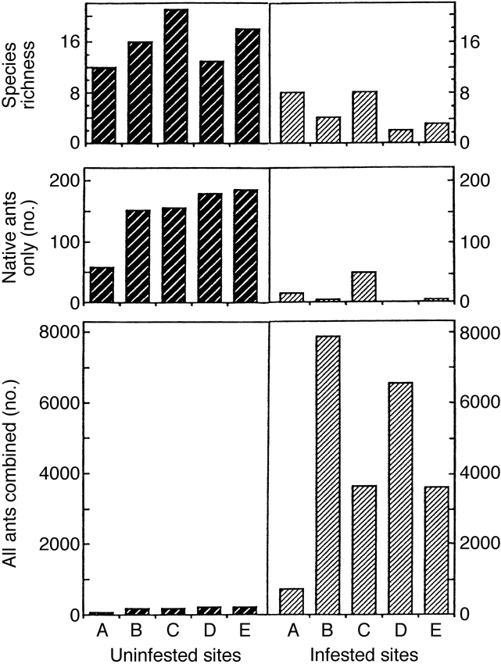
Brazilian fire ants have invaded Texas woodlands and grasslands and compete with native ants. Scientists tried to study whether the fire ants impact the diversity of ant communities. They set up pitfall traps to catch ants in sites that were either "infested" with fire ants or “uninfested.” Species richness is simply the number of species found in the traps. Look carefully at the scale of the y-axis when interpreting the graphs.

A. What are the independent and dependent variables in this study?

B. What points are the authors are trying to make with this graph?

Human impacts on the nitrogen (N) cycle

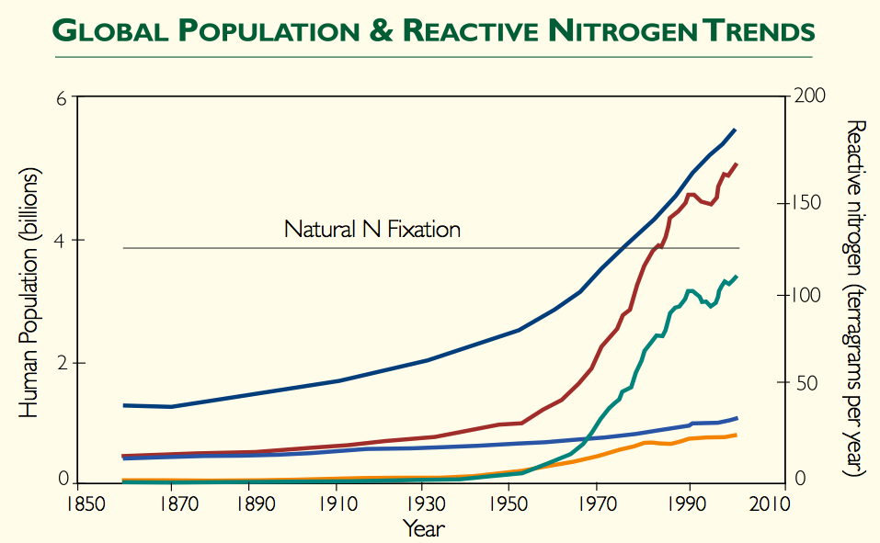

Global Population

Total reactive N

Industrial
N Fixation

N fixation in cropland

Fossil fuel N

Figure copyright 2003, the Hubbard Brook Research Foundation. Used with permission. All rights reserved.

1A. What is the primary purpose of the Haber-Bosch process?

1B. List the dependent and independent variables in this study.

1C. What main points about the nitrogen cycle are the authors are trying to convey with this graph?

1D. “Non-reactive” nitrogen is the common N2 gas in the air. Globally, natural systems produce 100-140 Mt of “reactive” nitrogen each year. For how long has human activity doubled the amount of reactive nitrogen cycling though ecosystems?

1E. As the human population grows from 6.4 billion to 9-10 billion over the next 50-70 years, what do you project to be the future trajectories (paths) of each of these lines? What factors and changes might cause the lines to change from their current course?

Climate Change, long-term data and noise: Changes in Lake Ice on Lake Mendota, WI

Introduction
One challenge to our understanding of environmental effects due to global warming is lack of data collected over long periods of time. Almost any environmental variable will exhibit variation over the short term. If we try to interpret trends or patterns from short-term data sets, we might come to a wrong conclusion. Can you think of an example to illustrate this point?

In most areas of science, it is rare to have a long-term data set. Few studies are funded for more than a few years. In this lab you will work with an unusually valuable data set in that it spans over150 years (1855-2006).

Plotting the lake ice records for Lake Mendota
The data for this lab come from Wisconsin's Lake Mendota, which is part of the North Temperate Lakes Long-Term Ecological Research (LTER) sites. The scientists recorded several variables that we could use:
- The date of "ice on" in the fall or winter (first day ice covers the lake)
- The date of "ice off" in the spring (when ice breaks up)
- The duration (number of days) of complete ice cover

1. How would you predict each of these measures to change in response to global warming? Why?

2. Why might these measures be more useful than periodically recording air temperature directly?

Examine the spreadsheet of data in Excel.
Download the data from Course Documents on Blackboard. This spreadsheet includes the original ice data collected at Lake Mendota over a 150-year period.
- Look at the headings at the top of the columns to make sure you understand each variable.
- Take a look at the first row of data, for the winter of 1855-56. In this winter, the ice froze on December 18 and melted on April 14. So the "Ice Duration" was from Dec. 18 to April 14, a total of 118 days.
- Some years the "ice duration" is less than the difference in these two dates because the ice broke up temporarily between "ice on" and "ice off" dates.

Make a graph by hand to look for 20-year trends.
Suppose that you are a scientist living in some period between 1855 and 2006. You are relatively fortunate to have 20 years of data on ice cover from Lake Mendota. Pairs of students will be assigned a 20-year period to look for trends in ice duration. For now, look ONLY at your 20 year period.

You will be given scrap paper to ROUGHLY plot your 20 years of data. Discuss what should go on the x-axis and y-axis. This is just a quick sketch to look for general trends; do not worry about precise values. This exercise will help you think about how to set up your graph in Excel.

Make a scatter plot in Excel.
- As done in the population growth lab, first highlight the x-axis variable and its values.
- While holding the control key (or apple key on a Mac), highlight the y-axis variable and its values.
- Insert a chart, and choose a scatter-plot format (called "XY Scatter").
- Adjust the graph to your tastes. Should you connect all the dots? (See handout on making scatterplots).

Interpret your Excel graph:
3. A. Do you see a trend in the duration of lake ice cover? That is, as time elapses, does the value tend to increase, decrease, fluctuate more, fluctuate less, stay the same, etc.?
B. What is the average duration of lake ice cover over your 20-year interval? (Use a formula in Excel to calculate this: “=average()” and then select the cells to be averaged.)
- Before proceeding, each group will show their screen to the class and note any trends.

Plot the entire data set of 150 yrs.
- Selecting whole columns is faster than selecting individual cells!
4. A. Do you see a trend in the duration of lake ice cover for the whole data set of 150 years?
B. What are some of the longest and some of the shortest periods of ice duration in the entire data set? In what years do they occur?
C. Calculate the average ice duration for the entire data set. In what time periods is the ice duration typically above that average? When is it typically below the average? .

Insert a trendline:
Choose Chart from the main menu, then Add trendline. The default linear trendline is fine.
Choose Options → Display equation on chart.
5. A. What is the equation for the line from the whole data set?
B. What does this equation mean (in words)? For example, how much does the duration of lake ice change every 100 yrs?
C. Summarize the 150 year trend with a hand-drawn sketch, and simply plot the average line (not every point!). Now sketch what a line would look like for a much smaller lake, and a much larger lake. Label each.

The big picture.
6. A. Look again at the Excel chart of the entire data series. By themselves, are these data on lake ice compelling evidence of global climate change? Why or why not? Are there any alternative explanations for the trends here?
B. What other evidence would you seek to determine whether the trends here are truly a result of global climate change?
C. If we have a cold wet summer, then does that mean global warming is not happening as fast as climate experts suggest? Explain
D. The year 2005 had a record number of hurricanes, including the infamous Katrina. Does that mean severe global warming is already upon us? Explain.
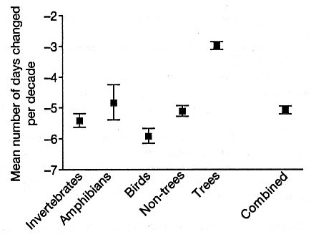
Responses in biota to climate change
This graph is a "meta-analysis" of 143 studies of almost 1500 different species (Root et al 2003, Nature 421:57-60. © 2003 Nature Publishing Group). For each species, scientists recorded the “phenology,” or timing when important events happened in each species' life cycle such as date of egg laying, migration, flowering, etc. These events were examined for over 30 years in most studies. The graph presents whether there have been any significant changes over time. A negative change means the events (e.g,. migration) were happening earlier in the spring or later in the fall.

7A. Is the basic message of this graph consistent with the data on duration of lake ice? Why or why not?
7B. How do the rates of change in biota compare to the rate of change from lake ice data over the same time period (1970-2003)? Explain the difference: speculate why one changes much faster,
7C. What could be some implications of the changes in this figure of changes to the biota? How might communities of species be affected?

Instructors’ Notes:

Number of days of lake ice on Lake Mendota, WI over the last 150 years. Students produce this graph from the LTER data available at http://lterquery.limnology.wisc.edu/abstract_new.jsp?id=PHYS.
The raw data may be difficult for students to access directly; the instructor should prepare a file with the data ahead of time.

This exercise is effective at helping students understand that annual variation is the norm in ecology, and that long-term trends are more important than short-term fluctuations. This exercise also helps students learn and apply the concept of slope in a scatterplot.

Genetically Engineered Organisms

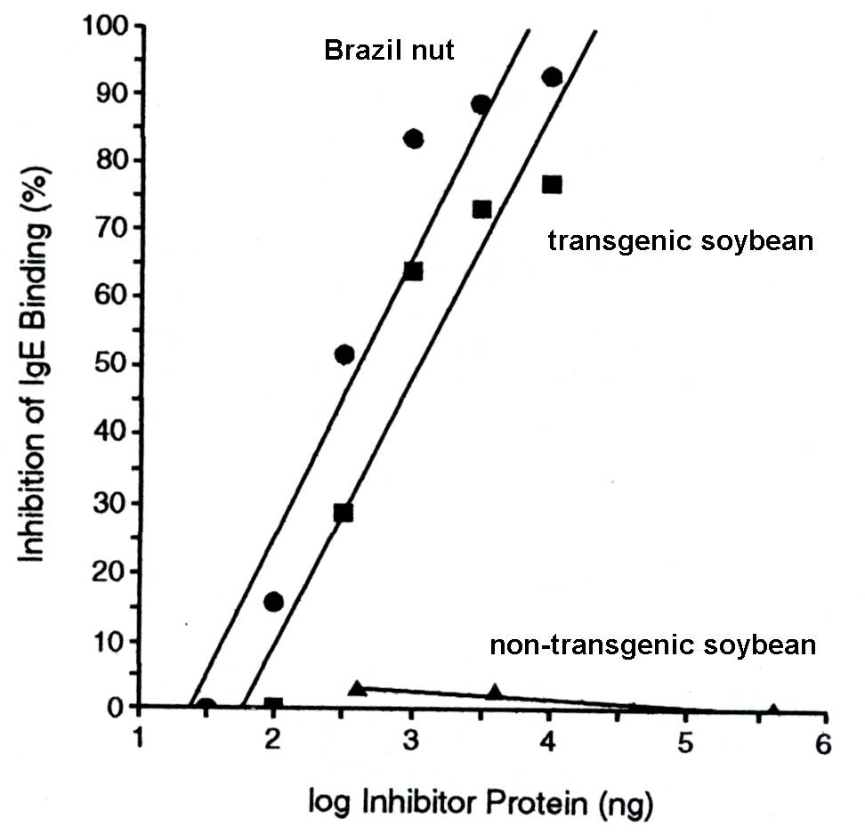
Figure 1. Results of Radioallergosorbent Assays with Extracts of Non-transgenic Soybean (triangle), Transgenic Soybean (square), and Brazil Nut (circle). Concentration of 2S albumin (in nanograms, log scale) in each dilution of extract in relation to percent inhibition of IgE binding. Read the x-axis as "Concentration of substance" and read the y-axis as "Potential allergic response via RAST test." (From Nordlee et al. 1996. Identification of a Brazil-nut allergen in transgenic soybeans. The New England Journal of Medicine 334: 688-692. Copyright © 1996, Massachusetts Medical Society. All rights reserved.)

Soybeans are nutritional superstars by providing essential dietary amino and fatty acids. In addition, consumption of soy products have been shown to reduce cholesterol levels, and reduce risks of kidney and heart disease, osteoporosis, and possibly some cancers. However, soybeans are not a "complete" protein source for people and animals since soybeans lack the essential amino acid methionine (“essential” here means that animals cannot create methionine themselves). To rectify this deficiency, plant biotechnologists used methods of recombinant-DNA technology to insert a gene into a strain of soybeans to enable them to synthesize this missing amino acid.
The problem with this approach was that the original source of the gene for methionine, "2S albumin," came from Brazil nuts (Bertholletia excelsa). Many people are allergic to Brazil nuts and their reaction can range from severe rashes to anaphylactic shock. The study we focus on here by Nordlee et al. (1966) addresses this issue.
The purpose of the study by Nordlee et al. (1996) was to determine the extent to which the transgenic soybeans, containing the Brazil nut 2S albumin gene, caused allergic reactions similar to Brazil nuts.
Figure 1 is based on data from a radioallergosorbent test (RAST) in which a sample of blood from a potentially allergic person is checked for allergic sensitivity to specific substances. The approach used by the RAST is to determine whether specific IgE antibodies in serum drawn from sensitized subjects are able to recognize the protein of interest, in this case the 2S albumin from Brazil nuts.
Discuss the following:
Start by taking 5 minutes to interpret the Figure. Run through your ten steps for yourself; you may wish to provide a short list of answers to those questions to help you answer the questions below.
Discuss answers to the following:
- What were the main research questions the scientists were asking?
- What was the benefit of conducting this test to determine the allergenicity of trangenic soybeans?
- Contrast the slopes of the 3 treatments; what conclusions can you draw about the relative allergenicity of the transgenic soybean?
- Did Pioneer Hi-Bred International (Dupont) make the right decision to abandon this research program? What were some alternatives?
- The ethical question of whether transgenic foods should be labeled is hotly debated. Can you assess the value or importance of this experiment within the context of bioethics? Should governments require labeling of genetically engineered foods?
- According to statements made by FDA Commissioner Dr. J. D. Henney (Thompson 2000, see Background to Figure Set 1) "we have no scientific evidence to indicate that any of the new proteins introduced into food by biotechnology will cause allergies." Based on your understanding of Nordlee et al. (1996), is Dr. Henney correct? Explain your response.

Glossary of terms
Allergy- overreaction of the immune system to specific substances called allergens (such as pollen or bee stings) that in most people result no symptoms. Allergies often involve IgE (one of the 5 types of immunoglobulins produced by humans) antibodies.
Allergen- an antigen that produces allergic reactions by inducing formation of IgE.
Antibody- proteins, produced by the immune system, that recognize a foreign substance and starts a process of removal of the foreign material from the body.
Antigen- a substance that stimulates the production of an antibody (see Allergen)
Immune system- a system in mammals that recognizes and then eliminates or neutralizes foreign substances.
Immunoglobulin- a group of proteins active in the immune system that serve as antibodies. They work by binding to foreign antigens.
BIO 103 Transgenics activity.
Work together in groups of four. Pair with one other person in the group. In each pair, one person should work on the problem while the other coaches. Choose who will have each role for the first two figures then switch roles for the two figures
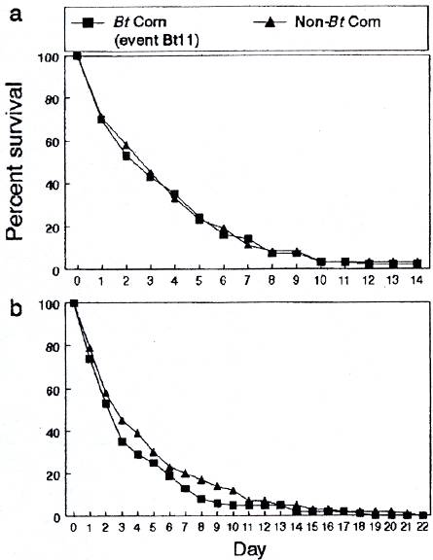

Figure 2a. The survival of second to third-instar monarch larvae was tested. Three milkweed leaf treatments were conducted: leaves with no pollen (grey), leaves treated with untransformed corn pollen (hatched), and leaves dusted with pollen from Bt corn (white). The mean survival rate is based on the proportion of larvae surviving in five replicates of each treatment (from Losey, H. E., L. S. Rayor, and M. E. Carter. 1999. Transgenic pollen harms monarch larvae. Nature 399: 214. © 1999 Nature Publishing Group.)

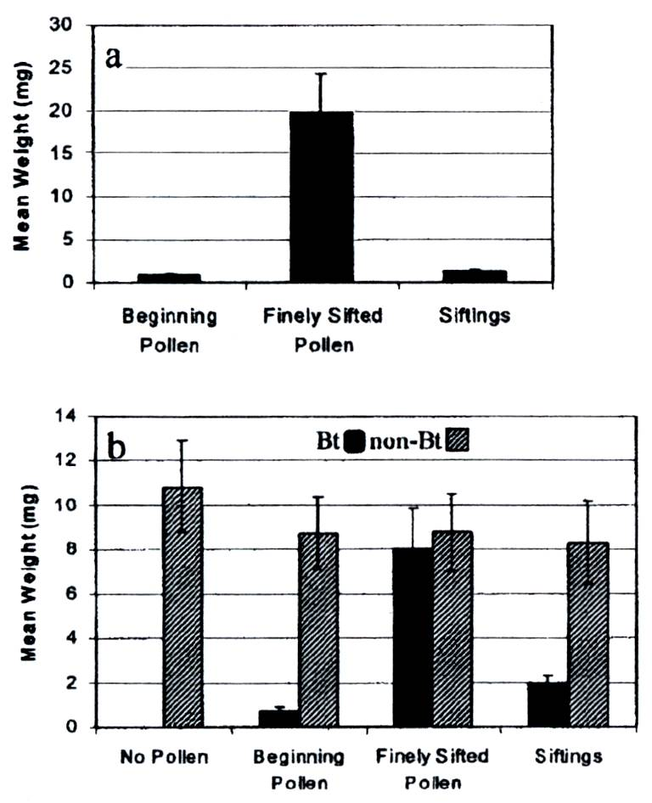
Figure 2b. Survival curves for monarch larvae placed in and near Bt and non-Bt corn fields. Survival curve (a) is based on data from Iowa and survival curve (b) is based on data from New York (from Stanley-Horn, D. E. et al. 2001. Assessing the impact of Cry1Ab-expressing corn pollen on monarch butterfly larvae in field studies. Proceedings of the National Academy of Sciences 98: 11931-11936, © 2001 National Academy of Sciences, U.S.A.)

Figure 2c. These graphs depict the mean weight of monarch larvae after feeding on treated milkweed for 96 hours. Treatments included: (a) pollen from hybrid G8539Bt that was processed with 250-µm sieve (beginning), pollen from same hybrid processed with 90-µm sieve (finely sifted), and siftings remaining after the initial sample was finely sifted; and (b) no pollen, pollen from hybrid N7070 with Bt inserted, and pollen from hybrid N7070 (non-Bt that were processed in the same manner as pollen in a) Hellmich, R. L. 2001. Monarch larvae sensitivity to Bacillus thuringiensis - purified proteins and pollen. Proceedings of the National Academy of Sciences early edition: 1-6, © 2001 National Academy of Sciences, U.S.A.).

First, examine Figure 2a. In this experiment, stems of milkweed leaves were put into tubes containing water. Five three-day-old monarch larvae (instar is a stage of development) were placed on each leaf.

In Figure 2a, compare larval survival after feeding on leaves with Bt pollen with those leaves dusted with untransformed pollen or the control leaves with no pollen.
Do you think the evidence indicates that differences in monarch larvae survival on leaves dusted with Bt pollen is due to the effects of Bt pollen?

Describe and interpret Figure 2b. Here the researchers sought to determine if there were significant differences in the numbers of larvae surviving in Bt corn fields and non-Bt corn fields in two different states, in order to analyze the toxicity of transgenic pollen on monarch larvae.

Does this new study discredit the original study? Explain why or why not.

Figure 2c is from an experiment conducted a couple years after the first study. It shows results of a contamination study. In this case researchers studied whether monarch larvae were affected by contaminants in the samples by comparing the varying levels of sifting of the pollen. Examine both figures.
How do larvae whose diet contained beginning pollen or siftings of the contaminated pollen compare with larvae that consumed finely sifted pollen (most contaminants were removed)?

What conclusion about the cause of the monarch larvae’s reactions to the samples can you draw from this figure?

Does this new study discredit the original study? Explain why.

Is the overall implication of this study similar to that of Figure 2b’s study?

What investigation(s) would you propose next?

Check your answers with the other pair in your group.
We have discussed the allergenicity of genes engineered into crops and whether crops engineered to resist pests might also impact non-target insects. Ecologists are also concerned about cross-pollination of transgenic plants with closely related weeds; plants are well known to hybridize across species and often produce fertile offspring. If weeds can mate with genetically engineered crop plants, their offspring may inadvertently express traits carefully engineered into those crops and become widespread pest- or herbicide- resistant weeds. Agricultural scientists are hard at work trying to discover ways that this cross-pollination can be prevented.

Morris and colleagues conducted an experiment to test the effectiveness of wide and narrow zones surrounding crop plants that are either free of plants (no trap) or planted with non-transgenic border plants (trap). They planted transgenic canola plants as the crop, and examined the frequency with which cross-pollinations occurred with closely related wild radish plants, strategically placed in a ring around the transgenic crop. Pollinators (bees, especially) were allowed to roam freely.

What is the dependent variable?
What is the independent variable?
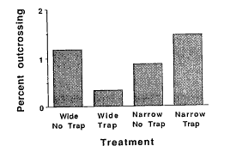
Draw what the graph would look like if barren zones were most effective in preventing the escape of transgenic pollen and increasing zone width improves effectiveness of pollen transfer prevention.

The effect of isolation zone width (narrow= 4m, wide = 8m) and of trap beds on the overall rate of gene escape from the transgenic canola plot. From Morris et. al.1994. Do barren zones and pollen traps reduce gene escape from transgenic crops? Ecological Applications 4: 157-165.

Which seems to be the most effective strategy for reducing the escape of transgenic pollen?

If there were statistically significant differences among our treatments, what could you say about the value of P in a statistical test comparing percent outcrossing among the treatments?

Extra credit: How might these results differ if we were using wind-pollinated corn, instead of insect-pollinated canola?
PRE-POST TEST for analytical skills

Name:______________________ Date: ______________

This survey is not graded. It will be used to check your progress through the course, so please answer to the best of your ability.

In a graph, the dependent variable….
A. is plotted on the x axis
B. is measured in the same units as the independent variable
C. is hypothesized to respond to changes in the independent variable
D. describes the experimental treatments

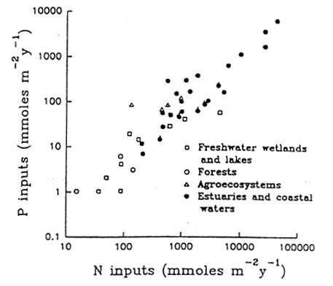
EXAMPLE #1.
Nitrogen (N) and phosphorus (P) are components of fertilizer. The figure to the right presents measurements of these nutrients in different types of ecosystems (Figure from http://tiee.ecoed.net/vol/v1/figure_sets/coral/coral_figure5.html.

1. Which is the best interpretation of the relationship between variables in this figure?
- Increasing amounts of nitrogen (N) cause phosphorous (P) to increase across ecosystems.
- Increasing amounts of phosphorous (P) cause nitrogen (N) to increase across ecosystems.
- N and P are positively correlated, while amounts depend on the ecosystems.
- Aquatic ecosystems have greater N and P availability than terrestrial systems.
- Both N and P increase together

2. List all the dependent and independent variables in this study:
Dependent: Independent:
EXAMPLE #2
Amphibians (frogs and salamanders) are declining worldwide. Two hypotheses for why this is happening are 1) pesticides and 2) predators.

To test these hypotheses, Reylea et al (2005) raised several frog species as tadpoles in small ponds. Some ponds had no predators, some had newts, and some had beetles. In addition to these treatments, ponds were exposed either to the insecticide Malathion, the herbicide Roundup, or no pesticide at all. This created nine different treatments:

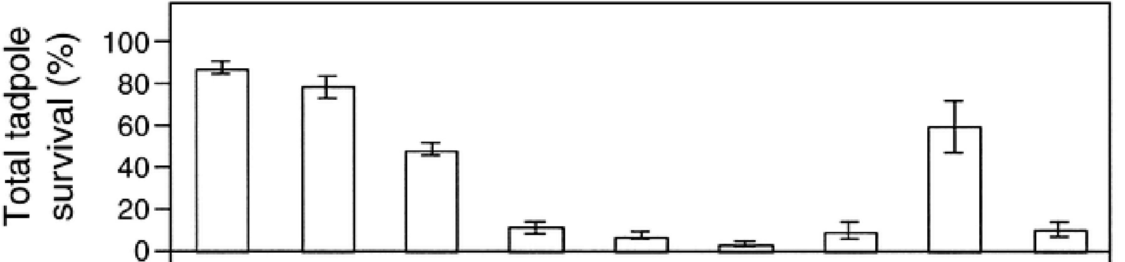

No predator
Newts
Beetles

No pesticide

Malathion

Roundup

No pesticide

Malathion

Roundup

No pesticide

Malathion

Roundup
No pesticide

Malathion

Roundup

No pesticide

Malathion

Roundup

No pesticide

Malathion

Roundup
No predatorNewtsBeetles

No predator Newts Beetles

Figure 2. Total survival of tadpoles living in experimental ponds with different pesticides and predators present. Data are means ± SE. Excerpted from Relyea at al. 2005, Ecol. Appl. 15: 1125-1134.

- Which treatment would you consider the “control”?

- Which treatment appears to have had the greatest impact on tadpole survival? Explain.

- Did both predators have the same effect on tadpoles? Explain.

- Did both pesticides have the same effect on tadpoles? Explain.

- Suppose you are managing a population of highly endangered frogs. Based on these results, would you want to ban pesticides tested in this experiment? Explain your answer.

EXAMPLE #3. A species of the tiny crustacean Daphnia lives only in deep lakes. You propose that their food limits this species to deep lakes, and you want to test that hypothesis. You feed Daphnia food from deep lakes where it normally lives and feed them food from shallow lakes and compare how well they grow and reproduce in each treatment.

# Eggs per female .
Replicate Deep lake food Shallow lake food
1 25 14
2 19 11
3 21 16
4 28 10

8. Draw a graph on the axes at the right

that best summarizes the data that

this experiment produced.

9. Is your hypothesis supported or rejected from this experiment?

Explain your answer.

EXAMPLE #4. Rhododendron bushes are often found on acidic soils (acidic means lower pH). One hypothesis to explain this is that rhododendrons cause the soil to become more acidic. A second hypothesis is that rhododendrons grow better in acidic soils. To test this second hypothesis, we prepared pots of soil with a range of acidity between 4 and 6.5, and then measured the growth of planted rhododendrons. Suppose the data look like this:

Plant weight (g) Soil pH
82 4.5
69 6.5
74 5
87 4
75 5.5

10. Draw a graph on the axes at the right

that best summarizes the data that
this experiment produced.

11. In words, explain any pattern in the graph that you created. (Is there a relationship between pH and plant weight?)

12. Do these results support or reject the second hypothesis? Explain.

13. In general, how would you rate your level of anxiety and frustration when you are presented with graph data to analyze or interpret?
A. No anxiety or frustration
B. Mild
C. Moderate
D. High anxiety or frustration
E. Extreme anxiety and frustration

1 Adapted from http://TIEE.ecoed.net/teach/essays/figs_tables.html
In 2005, this question was open-ended: students were asked simply to describe the relationship in words. The multiple-choice options were developed from their answers and used in 2006, especially to offer misconceptions or weak answers as distracters.

