EXPERIMENTS
An assessment of assemblage nestedness in habitat fragments

Roarke Donnelly
Oglethorpe University
Atlanta, GA 30319
rdonnelly@Oglethorpe.edu

These Matryoshka dolls represent a set of perfectly nested assemblages if one assumes (a) each doll represents an assemblage, (b) doll size is positively correlated with species richness, and (c) and physical nesting of a smaller doll within a larger doll indicates that all the species in the species-poor assemblage are found within the species-rich assemblage.

Table of Contents:

ABSTRACT AND KEYWORD DESCRIPTORS...........................................................2

SYNOPSIS OF THE LAB ACTIVITY............................................................................5

DESCRIPTION OF THE EXPERIMENT
Introduction................................................................................................................7
Materials and Methods............................................................................................10
Questions for Further Thought and Discussion.......................................................12
References and Links..............................................................................................13
Tools for Assessment of Student Learning Outcomes............................................15
Tools for Formative Evaluation of This Experiment.........…....................................22
Instructions for Using NestedSim.exe........…..........................................................24

NOTES TO FACULTY................................................................................................16

STUDENT COLLECTED DATA………………………………………………………..…26

COPYRIGHT AND DISCLAIMER...............................................................................26

CITATION:
Roarke Donnelly. 23 February 2009, posting date. An assessment of assemblage nestedness in habitat fragments. Teaching Issues and Experiments in Ecology, Vol. 6: Experiment #5 [online]. http://tiee.ecoed.net/vol/v6/experiment/assessment_assemblage/abstract.html

ABSTRACT
This experiment illustrates how ecological theory can help conserve native species in a fragmented landscape. It is germane to units on biogeography, human impacts on ecosystems, landscape ecology, conservation, and restoration. During the first lab, the instructor introduces the process of habitat fragmentation, the degree to which species in species-poor assemblages are proper subsets of species-rich assemblages (i.e., degree of nestedness), the possible relationships between fragmentation and nestedness, and identification of common breeding bird species in regional forest fragments. Between the first two labs, students practice bird identification, read about the general effects of fragmentation on bird populations and communities, and consider whether bird assemblages might be nested by specific attributes of habitat fragments. During subsequent labs and out of class time, student groups survey breeding birds in forest fragments, perform a statistical analysis, and assess the relative merits of the alternative hypotheses. Student groups complete the experiment by presenting scientific research posters.

KEYWORD DESCRIPTORS

- Ecological Topic Keywords: alien species, assemblages, biodiversity, biogeography, bird community structure, community ecology, conservation biology, dispersal, disturbance, exotic species, extinction, habitat fragmentation, human impacts, invasive species, landscape ecology, management threshold, native species, nest predation, nestedness analysis, urban ecology, urban sprawl, and wildlife management

  - Science Methodological Skills Keywords: Classification, collecting and presenting data, correlation versus causation, data analysis, evaluating alternative hypotheses, field work, formulating hypotheses, graphing data, hypothesis generation and testing, identification skills, natural history, oral presentation, poster presentation, presence / absence analysis, statistics, random sampling, theoretical thinking, and use of spreadsheets

  - Pedagogical Methods Keywords: assessment, background knowledge, formal groupwork, and problem based learning

CLASS TIME

Four lab periods (minimum of 3 hours each) and one lecture period.

OUTSIDE OF CLASS TIME

Ten hours per student, based on the following: 2 hours to read in preparation for lab periods one and two, 3 hours for practice identifying organisms, 3 hours for data processing and analysis, and 2 hours to generate products for submission.

STUDENT PRODUCTS

A short report with alternative hypotheses and associated rationales, spreadsheets with fragment attribute data and field survey data, a short report with statistical and graphical analysis of the field survey data, oral discussion of results, and a scientific research poster.

SETTING

9 to 12 native habitat fragments varying in area and isolation.

COURSE CONTEXT

I use this experiment in a 400-level general ecology course for biology majors at Oglethorpe University. A typical course section has around 9 students. I divide the section into three groups that work independently.

INSTITUTION

Oglethorpe University is a small private liberal arts institution with a largely undergraduate enrollment. It is located in a suburb of Atlanta, GA.

TRANSFERABILITY

This experiment can be transferred to other mid- to upper-level courses for science majors (conservation biology, landscape ecology, and environmental science), larger lab sections, other taxa, and other ecosystems. It is not appropriate for students with significant physical disabilities and is not easily scheduled outside of late spring/early summer if breeding birds are used.

ACKNOWLEDGEMENTS

A few years back, I wanted to test whether assemblages were nested by attributes of habitat fragments. Direct statistical tests were only performed by a handful of people, including Erica Fleishman (Stanford University and National Center for Ecological Analysis and Synthesis). Erica was helpful, knowledgeable, and supportive regarding these tests, so we talked a great deal about nestedness and its potential to inform conservation planning. With the able support of John Fay (Stanford University and Duke University) and Rick Reeves (National Center for Ecological Analysis and Synthesis), we updated the format of the existing statistical tests so that they functioned on common computing platforms and published a manuscript on nestedness analyses and conservation planning. Bruce Patterson (Field Museum of Natural History) and Wirt Atmar (AICS Research) graciously provided historical context, encouragement, editorial assistance, and humor throughout the production of the manuscript. While the manuscript was in review, I designed this experiment in the hopes of engaging more students with problem-based and active learning. This idea would not have occurred to me but for my exceptional mentors from the University of Washington: Elizabeth Feetham, Marsha Landolt, and John Marzluff. Two TIEE reviewers and an associate editor provided extremely helpful comments on a draft of this exercise.

Synopsis of the Experiment
Principal Ecological Questions Addressed

What is habitat fragmentation? How does habitat fragmentation affect bird populations and assemblages? What are the proximate and ultimate causes of these fragmentation effects? Why are bird assemblages in habitat fragments often nested? Are bird assemblages in regional habitat fragments nested by fragment attributes? If these assemblages are nested by fragment attributes, how can this pattern guide bird conservation on the landscape?

What Happens

Students survey birds in forest fragments in order to: (1) test whether bird assemblages are nested by attributes of habitat fragments and (2) identify thresholds in fragment attributes that are relevant to conservation planning. Students begin by studying the impacts of fragmentation on bird populations, the theory and analysis of assemblage nestedness, and identification of bird species. They read about and discuss proximate and ultimate causes of assemblage structure, survey organisms in forest fragments, use freeware to test for assemblage nestedness and graph results, compare the degree to which assemblages are nested by different attributes of habitat fragments, and generate conservation plans. To complete the experiment, students produce and present scientific research posters.

Experiment Objectives

- Explore the process of habitat fragmentation and how it alters habitat suitability and species occupancy

- Learn how to identify bird species in the field

- Use nestedness analysis to test hypotheses regarding the relative impacts of different aspects of fragmentation on bird assemblage structure and to generate a conservation plan

- Consider the benefits and risks of using presence/absence data and proximate ecological mechanisms to guide conservation efforts

Equipment/Logistics Required

Each student group needs:

- one pair of binoculars,
- one field guide to bird identification,
- one CD of bird songs by species common to the region,
- and one field notebook (preferably a smallish spiral bound book by rite-in-the-rain).

The class needs:

- access to at least one IBM compatible personal computer
- and one global positioning system unit (only necessary if the instructor needs help driving to fragments for the bird surveys).

The computer must have the following software (Microsoft Excel, GoogleEarth [freeware available on the internet], Nested [freeware provided)], and Threshold [freeware provided]). It must also have the minimum specifications necessary to run GoogleEarth. At the time of publication, these specifications were: Pentium 3, 500Mhz, 128M RAM, 400MB disk space, network speed: 128Kbits/sec, 3D-capable video card with 16Mbytes of VRAM, and 1024x768 "16-bit High Color" screen.

Summary of What is Due

Between the first and second lab period:

- each student must take a quiz on bird species identification,
- each student must read about fragmentation effects on birds (Faaborg 2002, chapters 4-5) and generate a brief written report explaining why smaller and more isolated habitat fragments tend to support fewer bird species than larger and less isolated habitat fragments,
- and each group must enter its estimates of fragment area and isolation into the provided spreadsheet and submit the edited spreadsheet.

After the remaining field data have been collected during the fourth lab period, each group must:

- add the data from the bird surveys to the spreadsheet edited between weeks one and two and submit the edited spreadsheet,
- submit statistical results and meet with the instructor to discuss interpretation of results,
- submit a rough draft of the scientific research poster,
- and present the final draft of the scientific research poster to the instructor and class.
Description of the Experiment

Introduction

As loss of native habitat by human action reduces the total area of native habitat on the landscape, the remaining fragments of the native habitat (hereafter termed habitat fragments) shrink in area and become increasingly isolated from each other. Since reduction in total native habitat area and changes to habitat fragments are inextricably linked, “habitat fragmentation” has referred to (1) total habitat reduction and change to habitat fragments and (2) change to habitat fragments alone (Villard 2002). This experiment—and most of the recent literature—follows the second, more restrictive convention.

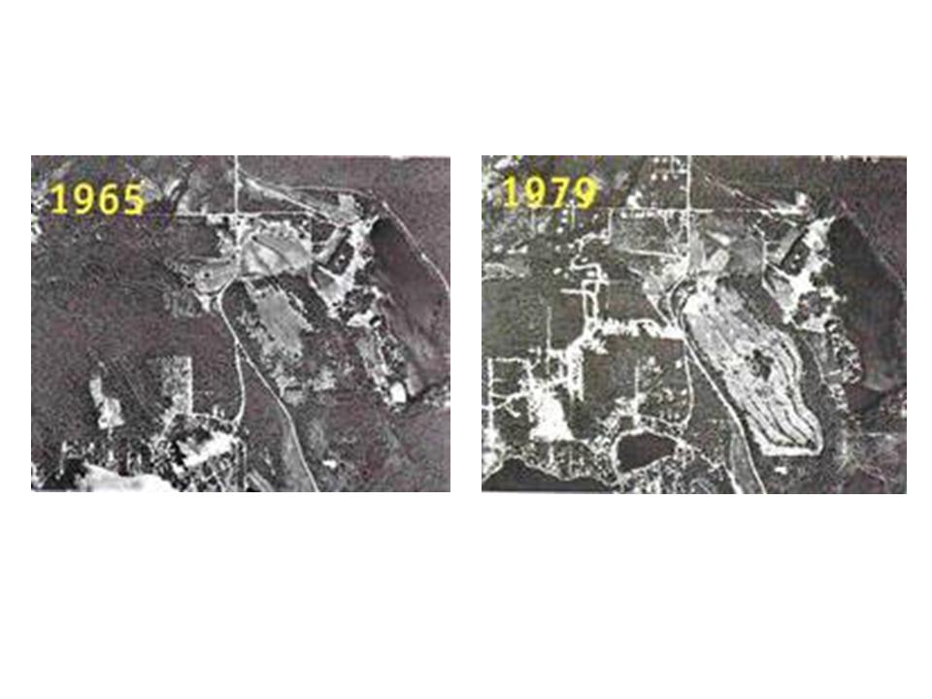
Figure 1. Aerial photographs of a landscape near Seattle, WA that was fragmented between 1965 and 1979. Note that native habitat fragments are smaller and more isolated in the latter image. These changes are hallmarks of habitat fragmentation.

Habitat fragmentation is an important ecological concept for two reasons:
- Many native terrestrial and wetland habitats are experiencing rapid rates of habitat loss and associated fragmentation. For example, the area of isolated forest in the Brazilian Amazon increased 317% between 1978 and 1988 (Skole and Tucker 1993) and the average forest fragment in metropolitan Seattle, WA shrank by 246ha between 1974 and 1998 (Robinson et al. 2005).

- Habitat loss, habitat fragmentation, and reduction in habitat quality (i.e., degradation) are the most common causes of species listing and proposed listing under the US Endangered Species Act (Flather et al. 1998, Wilcove et al. 1998) and the second most common cause of species endangerment in some developing countries (Li and Wilcove 2005).
The negative effects of fragmentation on native bird species in forests have been particularly well studied. As fragments decrease in area, the proportion of each fragment that is edge habitat increases. Edge habitat is situated within the focal habitat type, but close to its boundary. It tends to have more solar radiation, shrub density, nest predators, brood parasites, and cover of invasive non-native plant species than core habitat (i.e., non-edge habitat). Thus, all else being equal, rates of nest predation, brood parasitism, and bird species extinctions are often higher for small fragments with a large ratio of edge to core than for large fragments with a small ratio of edge to core (Wilcove 1985, Faaborg 2002). Many bird species are also negatively affected by fragment isolation, despite their ability to fly. As fragment isolation increases, the probabilities of colonization by a new species and rescue by an individual from a recently extirpated species decrease for all but species with greatest ability to disperse among habitat fragments (Belisle et al. 2001, Desrochers and Fortin 2000, Cooper and Walters 2002).

For the reasons described in the preceding paragraph, the largest and least isolated habitat fragments in a fragmented landscape often contain the largest number of bird species (i.e., species richness) and are often the focus of efforts to conserve regional biodiversity (Diamond 1975, Shafer 1997). Defining a fragment’s conservation value with richness alone, however, has risks. Invasive species, species associated with edge habitat or human activity (i.e., synanthropic species), and native non-synanthropic species contribute equally to richness. Even if species classes are analyzed separately, they do not offer a straightforward means for calculating the values of fragment area and isolation where individuals tend to switch from present to absent. These values (i.e., management thresholds) are exceedingly useful to the natural resource managers and policy makers who decide which habitat fragments to protect. Assemblage nestedness is a useful alternative to species richness because it considers both species richness and identity and can produce management thresholds. Nestedness analyses use presence/absence data to determine if assemblages with x species richness tend to be found (i.e., nested) in assemblages with > x species richness.
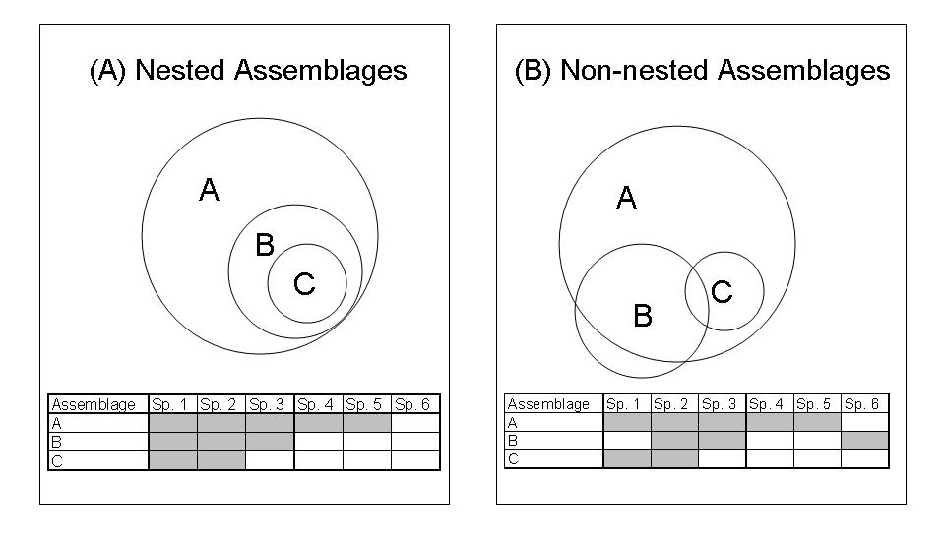Figure 2. Venn diagrams illustrating the nested subset relationship. Modified with permission from Fleishman et al. 2007.

Each panel in Figure 2 represents a biota composed of three local assemblages, indicated by circles A, B, and C. Circle size is positively correlated with species richness. Greater area of circle overlap [i.e., intersection] denotes greater number of shared species. The left biota is nested; the species present in relatively species-poor assemblages are present in relatively species-rich assemblages. The right biota is non-nested because some species present in C are absent from B and some species present in B are absent from A.). More to the point at hand, this type of analysis can directly and statistically determine whether assemblages in habitat fragments are nested by fragment attributes (Fleishman et al. 2007).

For this exercise, pretend that you work for a county near your school that has a mandate and limited funds to conserve native species in forest fragments. Your supervisor has approved your request to test the hypothesis that breeding bird assemblages in your county are nested by habitat fragment area and isolation. You proceed by:

- estimating the size and isolation of several pre-selected regional fragments,
- surveying the fragments to determine which breeding bird species are present,
- testing whether assemblages are nested by fragment area and/or isolation,
- determining management thresholds with respect to fragment area and/or isolation (e.g., protection of fragments >2.1ha will conserve 72% native breeding bird species in regional species pool),
- and presenting your recommendations for conservation planning in the form of a scientific research poster.
Materials and Methods

Study Sites

Obtain a spreadsheet from your instructor with the names and locations (i.e., latitude and longitude) of habitat fragments that you will use to test your hypothesis. Then, use software called GoogleEarth to locate those fragments and estimate their two-dimensional area and isolation. To get familiar with GoogleEarth, open the software and use the “fly to” tool in the upper left portion of the screen to find your school. Use the zoom tool on the upper right portion of the screen (you may have to roll the cursor over the tool for it to appear) to adjust your “height above the ground” so that the roof of your building fills most of the screen. Estimate the area of the roof using the “measure” tool and your knowledge of basic geometry. For example, if the roof is shaped like a rectangle, area equals the product of the lengths of two adjacent sides. Once you have checked your estimate of roof area with your instructor, use the latitude and longitude bar at the bottom of the screen and the measure tool to estimate the area of the habitat fragments described in the provided spreadsheet. After you estimate the area of a fragment, estimate its isolation before moving to the next fragment; this procedure will save you time. Estimate fragment isolation with the minimum straightline distance between a focal fragment and the nearest fragment of >10ha (equivalent to a circle with a 178m radius).

Overview of Data Collection and Analysis Methods

Week 1, during lab
Take notes on habitat fragmentation, nestedness, the hypothesis, research group organization, and data collection methods. Form groups of three students.

Between Week 1 Lab and Week 2 Lab
Enter your estimates of fragment area and isolation into the spreadsheet provided by your instructor. Read two chapters by Faaborg (2002) on the effects of habitat fragmentation on breeding birds. Practice identifying breeding birds by sight and sound. Take a quiz on breeding bird identification

Weeks 2 through 4, during Lab
During each of these labs, you will travel to several forest fragments to survey birds. If the forest is fairly easy to walk through, survey birds using a transect (Bibby et al. 1992). You may stop periodically on the transect, but keep moving at a slow pace if possible. Identify all species detected by sight or sound within 30m of either side of the line. For a fragment less than roughly 8ha, the transect area (i.e., 60m swath centered on the line) should cover nearly all of the fragment without double sampling any area. For a larger fragment, the transect should cover a representative area at least as large as the area covered in smaller fragments. If the forest is difficult to walk through, survey birds with point counts (Bibby et al. 1992). At each point, remain still and silent for 1 minute, then identify all species detected within a 40m radius during the following 6 minutes. Follow the fragment coverage rules described for transects. Transects and points can be established prior to the visit using GoogleEarth and located in the field with a global positioning system unit. If possible, survey birds during the bird breeding season between sunrise and 4 hours after sunrise. Season is more important than time of day.

After the Last Lab
Add your group’s bird survey data to that spreadsheet. This should be accomplished by adding a column for each bird detected within at least one fragment. Note the species’ common name at the top of the column and indicate the presence or absence of the species in a fragment with a “1” or “0”, respectively.

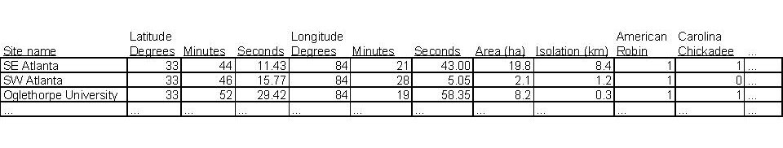
Figure 3. Format for entry of bird survey data into spreadsheet with site/fragment name, area, and isolation. Note that isolation is expressed as straightline km from the center of mass within the focal fragment to the center of mass in the nearest fragment that is >10ha.

To complete data formatting and statistical analysis, consult the instructions for using NestedSim.exe. If the value of %PN (i.e., your test statistic) is associated with a P-value less than or equal to 0.05, the assemblages are more nested than 95% of 1000 random simulation and the statistic is said to be significant. In other words, the high degree of nestedness is unlikely to have arisen by chance and your data support one of your hypothetical mechanisms. For each significant statistic/ assemblage, produce a spreadsheet showing species presence or absence in each fragment (i.e., presence/absence matrix) with a species occurrence threshold curve using the excel file named Threshold; for directions on how to operate the software, see the file’s worksheet titled instructions. The species occurrence threshold curve describes the line of smoothest transition between species-specific occurrence thresholds, or the value on a matrix’s y-axis that is likely to divide presence of a given species from absence of that same species. Use this curve to extrapolate thresholds on the y-axis corresponding to conservation of 75, 50, and 25% of the regional pool of breeding bird species.

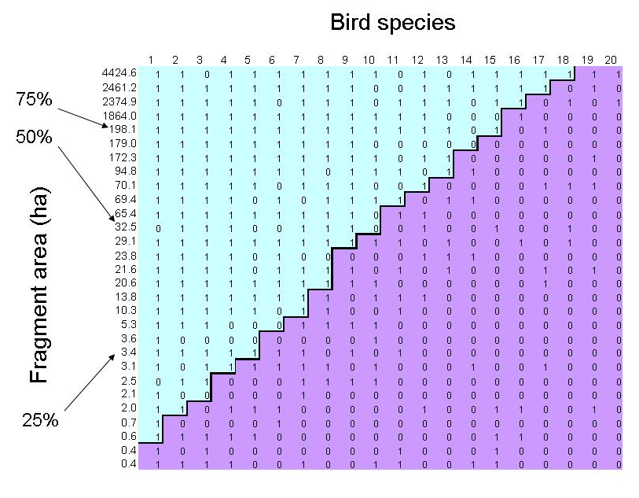
Figure 4. Output of program within excel file named threshold. The jagged line across the presence/absence matrix represents the species occurrence threshold curve. Notations indicate the minimum habitat fragment size predicted to contain different percentages of the regional pool of breeding bird species. For example, Fragments of at least 198.1ha will tend to support 75% [15/20] of the regional pool.

Questions for Further Thought and Discussion

- As mentioned earlier, the processes of habitat loss and habitat fragmentation are inextricably linked and have often been confused due to lack of standard terms. On which process do you think conservationists should focus? Why? (Search the literature for manuscripts by Henrik Andren and by Lenore Fahrig)

- Describe three ways that fragmentation decreases the potential for some species to successfully breed and occupy smaller and more isolated forest fragments. For a review, see Faaborg (2002).

- Why might species-specific dispersal ability or species-specific extinction probability produce nested assemblages of organisms in habitat fragments? Would you expect one of the mechanisms to explain nestedness of bird assemblages more often than the other? What other explanations for nestedness exist in the literature?

- If one explains assemblage nestedness in native habitat fragments with species-specific extinction probability, what must be assumed about the studied fragments prior to their separation from adjacent native habitat?

- What is the primary weakness of all presence/absence analyses and how might they affect conservation decisions emanating from those analyses? (Search the literature for recent manuscripts by Christina Vojta and by E. Fleishman)

- In the 1980’s, conservation planners debated the relative merits of using limited funds to protect a single large fragment or a collection of several small fragments that have the same combined area as the large fragment. This debate is often referred to as the Single Large Or Several Small (SLOSS) debate. How might nestedness analysis bear on this debate?

- Assume that bird assemblages in your county’s forest fragments are nested by fragment area. Would it be useful for you to study how fragment area leads to assemblage nestedness? In other words, would knowledge of the mechanism improve the outcomes of your management activities?

References

- Belisle, M., A. Desrochers, and M-J. Fortin. 2001. Influence of forest cover on the movements of forest birds: a homing experiment. Ecology 82:1893-1904.

- Bibby, C., N.D. Burgess, and D.A. Hill. 1992. Bird Census Techniques. Academic Press, New York.

- Cooper, C.B. and J.R. Walters. 2002. Experimental evidence of disrupted dispersal causing decline of an Australian passerine in fragmented habitat. Conservation Biology 16:471-478.

- Desrochers, A. and M.-J. Fortin 2000. Understanding avian responses to forest boundaries: a case study with chickadee winter flocks. Oikos 91:376-384.

- Diamond, J.M. 1975. The island dilemma: Lessons of modern biogeographic studies for the design of natural reserves. Biological Conservation 7:129-146.

- Faaborg, J. 2002. Saving migrant birds: developing strategies for the future. University of Texas Press, Austin.

- Flather, C.H., M.S. Knowles, and I.A. Kendall. 1998. Threatened and Endangered Species Geography. Bioscience 48:365-376.

- Fleishman, E., R. Donnelly, J. Fay, and R. Reeves. 2007. Applications of nestedness analysis to conservation of biodiversity in developing landscapes. Journal of Landscape and Urban Planning 81:271-281.

- Li, Y. and D.S. Wilcove. 2005. Threats to vertebrate species in China and the United States. BioScience 55:147-153.

- Robinson, L., J. Newell, and J. Marzluff. 2005. Twenty-five years of sprawl in the Seattle region: growth management responses and implications for conservation. Landscape and Urban Planning 71:51-72.

- Shafer, C.L. 1997. Terrestrial nature reserve design at the urban/rural interface. In Conservation in highly fragmented landscapes (M.W. Schwartz, ed.), pp.345-378. Chapman and Hall, New York.

- Skole, D. and C. Tucker. 1993. Tropical deforestation and habitat fragmentation in the Amazon: Satellite data from 1978-1988. Science 260:1905-1910.

- Villard, M. 2002. Habitat fragmentation: major conservation issue or intellectual attractor? Ecological Applications 12:319-320.

- Wilcove, D.S. 1985. Nest predation in forest tracts and the decline of migratory songbirds. Ecology 66:1211-1214.

- Wilcove, D.S., D. Rothstein, J. Dubow, A. Phillips, and E. Losos. 1998. Quantifying threats to imperiled species in the United States. Bioscience 48:607-615.

Tools for Assessment of Student Learning Outcomes

This experiment proceeds in six stages that build upon one another. For the first two stages, each member of the group must submit independent work and will receive an independent grade. For the last four stages, all members of a group will receive the same grade. Here is a description of each stage:

- Prepare to identify birds by sight and sound in the field by studying for and taking a quiz. The quiz will test your knowledge of bird anatomy and song relevant to field identification. At least part of the quiz will take place outdoors.
- Read Faaborg (2002, chapters 4 and 5) to familiarize yourself with the well-documented effects of fragment size and isolation on bird species richness. Draft a report of about 1 page that summarizes the biological mechanisms underlying these fragmentation effects in your own words and links these effects to bird assemblage nestedness.
- Add the data on fragment area, fragment isolation, and bird species presence/absence to the spreadsheet provided by the instructors during the first lab. Your group will submit this spreadsheet twice. The first submission will be returned with comments on the accuracy with which you estimated fragment attributes. The second submission will be graded on your response to these comments, the inclusion of all bird presence/absence data, and the inclusion of a separate worksheet in the excel file that conforms to all of the formatting requirements for entry into program Nested (see the instructions for using NestedSim.exe).

- Test whether bird assemblages are nested with respect to fragment area and isolation using program Nested. Submit images of the computer output and all associated statistics calculated by hand (see the instructions for using NestedSim.exe).
- Prepare a scientific research poster on your experiment. The instructor will grade your poster based on the quality and relevance of information in each section (e.g., introduction), the clarity with which the poster communicates important concepts, and the ability of the group to answer questions posed by the instructor.
- Edit your rough draft poster using the comments from your rough draft. Your final draft of the poster will be graded on the degree to which you address prior comments and your ability to answer questions about your experiment posed by viewers at the poster session.

NOTES TO FACULTY

Challenges to Anticipate and Solve

- Communicating the idea of assemblage nestedness and how to test it. The idea of assemblage nestedness is not easily explained to those unfamiliar with community ecology. Luckily there are multiple ways to attack the problem that appeal to different types of learners. It is easiest to begin by comparing a small number of assemblages that are perfectly nested to a small number of assemblages that are imperfectly or only slightly nested. I suggest introducing the concept first with the Venn diagrams and presence/absence matrices in Figure 2. If some students are still grappling with the concept of nestedness, try the colorfully painted and familiar Matryoshka dolls (AKA Russian nesting dolls). A set of dolls represents a set of perfectly nested assemblages if you assume the following three rules:
- each doll represents an assemblage,

- doll size is positively correlated with species richness,

- and physical nesting of a smaller doll within a larger doll indicates that all the species in the species-poor assemblage are found within the species-rich assemblage.

Testing nestedness can be just as opaque as the concept of nestedness itself. It is best to discuss how %PN is calculated using the example dataset. Examine the presence/absence matrix and note deviations from perfect nestedness, how the statistical software quantifies deviations from the field data and simulations, and how both types of deviations contribute to the test statistic. See the first of the Questions for Further Thought below.

- Selecting field sites. If you have an extra lab or two to spend on this experiment, I suggest you have students select field sites. This is a difficult and time consuming part of such an experiment that teaches some of the difficulties inherent in conservation research (e.g., site access, confounding variables, minimum distance necessary for statistical independence of sites, etc.). Assuming you are selecting site, try to select fragments that reasonably cover the available ranges of fragment area (e.g., 3-300ha) and isolation (e.g., 0.1-3km). Identify more candidate sites than you need, check on access for each site, and visit each site to assess general comparability of sites (e.g., lack of extreme physical disturbance to understory and similarity of surrounding landuse). Once you have identified 9-12 viable sites, construct a spreadsheet with five labeled column for distribution to the students:
- Column 1 = Site name
- Column 2 = latitude
- Column 3 = longitude
- Column 4 = area (ha)
- Column 5 = isolation (km from closest fragment >10ha)

Columns one through three should have data filling row two through at least row 10.

- Keeping students on track. The entire experiment progresses quickly. Students who fall behind rarely catch up, make meaningful contributions to group work, and understand all concepts listed in the learning objectives. The best way to maximize the number of students who successfully complete the experiment is to design and clearly communicate appropriate grading incentives for the completion/submission of assigned work. I suggest using the grading rubric below. Additionally, I suggest that you require each student to evaluate his work and that of the students in his group as part of the final draft of the scientific research poster. I attach my peer evaluation form to the assignment sheet handed out during the first lab to inspire a more equitable distribution of work.

- Sorting bird species for nestedness analyses. Bird species have different levels of affinity/aversion for humans and the results of human activities. Most urban ornithologists refer to species that regularly associate with humans or benefit from them as synanthropic and those that do not regularly associate with humans or benefit from them as non-synanthropic. Patterns of nestedness, if present, will be most apparent if student groups sort bird species into these two groups and analyze them separately. See Donnelly and Marzluff (2004) for analyses of sorted species and Johnston (2001) for species sorting.

- What if bird assemblages are not nested by fragment area or isolation? It is possible that students will find that bird assemblages are not nested by fragment area or isolation. If this occurs, it is useful to discuss potential explanations for the results and what additional fragment attributes—if any—should be explored if time allowed. Potential explanations for these results include:
- fragment area and isolation are not important to bird species in the landscapes where data were collected,

- one visit per site was not enough to accurately determine species presence or absence,

- and there was not enough variation in fragment area and isolation among the selected fragments.
The last potential explanation is likely too be true of isolation in landscapes with >40% native habitat on the landscape; in this case, all fragments are relatively close to one another and likely to exchange individuals. For more information, see the first “Question for further thought”.

- Managing the poster session. While driving among field sites, I spend a fair bit of time explaining that poster sessions are a typical part of annual meetings for major academic societies, are an alternative format to oral presentations with greater interaction between presenter and audience, and may be an important step toward a published manuscript. To communicate poster format and content, I refer students to Purrington (2006). Finally, I try to simulate the environment of a real poster session by providing munchies and an audience of lower level biology students and biology faculty.

Experiment Description

Introducing the Experiments to Your Students

I run this experiment during the mid- and latter-stages of my upper-level General Ecology course, after covering abiotic and biotic factors limiting species distributions and equilibrium theories of species richness. Much of this material is heavily steeped in theory and can put the students to sleep even if you try to illustrate it with real world examples. One can regain the attention of the theory-resistant students by introducing this experiment as a chance to apply theories already studied to conservation planning. Who can resist saving imperiled species?

Data Collection and Analysis Methods Used in the Experiment:
The most challenging portions of this experiment for the students are bird identification and statistical analysis. It is much easier to identify birds to the species level than individuals of many other taxa. However, students may need training on binocular operation, bird morphology relevant to visual identification, and identification of species by sound. Have the students practice the act of quickly locating and focusing on stationary birds or fixed objects. If conducting the lab in North America, use the Golden Guide to Birds of North America (Robbins et al. 2001), Thayer’s Guide to Bird Identifcation (Thayer 1998), and/or the Patuxent Wildlife Research Center’s website (Gough et al. 1998) to practice bird identification. The Golden Guide has a nice description and figure of external bird morphology near the front of the book and printed sonograms for most species. The latter is very rare in field guides. The CD has pictures, audio clips, sonograms, and mnemonic devices for song identification. It is best if students use the book and the CD in the lab to learn a reasonable number of the species most likely to be encountered during the experiment. Even if students have some experience with bird identification, I highly recommend looking over their shoulders during bird surveys to ensure that they detect species that are present and do not detect species that are absent. Students typically find some species easier to identify than others. As long as these abilities/limitations do not overlap excessively, a group of three students will be able complete a relatively accurate survey with minimal input from the instructor.

Statistical analysis runs smoothly if you use an example dataset to illustrate formatting of data for input, running of the software, and production of graphics associated with the statistics. All necessary files, including results of example dataset analysis are available under the Downloads page.
There are many ways for students to collect the data necessary for this experiment. In order to save time in the lab, I suggest instructing each group to estimate area and isolation for a subset of the forest fragments and to enter their results into a common excel file that will be disseminated to all groups. This system is effective as long as individual groups do not produce consistently biased estimates of area and or isolation. I suggest a slightly different approach to surveying birds. Have each group record all birds that it detected on a transect. Then, pool the species lists from all groups for that transect to create an aggregate species list for that transect, or fragment. This approach will compensate for considerable variation among students in the ability to identify bird species. The wise instructor will still—as much as possible—monitor bird identifications in the field.

Questions for Further Thought

- Unfortunately, there is no simple answer. Theoretical, meta-analytical, and empirical studies (Andren 1994, Fahrig 1997, Bunnell 1999, Harrison and Bruna 1999, Lichstein et al. 2002) suggest that habitat loss is more detrimental to retention of native species than habitat fragmentation until native habitat becomes fairly rare on the landscape; once the landscape falls below this threshold, habitat fragmentation is more important than habitat loss. Andren determined this threshold to be 30% native habitat on the landscape for birds and mammals, but the exact value is likely to vary among taxa and to be higher for less vagile taxa. To demonstrate thresholds in fragment connectivity, use a simple applet available from the American Museum of Natural History (2007; exercise 9)

- See Faaborg (2002) for many acceptable answers. Most bird conservationists would put the following near the top of the list: smaller fragments have a larger edge to core ratio and higher nest predation rates, smaller fragments have a larger edge to core ratio and higher brood parasitism rates, and more isolated fragments have smaller chances of population rescue.

- If presence of species in a fragment is largely dictated by dispersal ability and species vary in their ability to reach (i.e., colonize) more distant islands, then assemblages in fragments will be nested. Species with poor dispersal ability will be absent from distant fragments, while species with good dispersal ability will be ubiquitous. If presence in fragments is largely dictated by extinction and species vary in their ability to persist in smaller fragments, then assemblages in fragments will be nested. Species that are sensitive to area, edge, or habitat degradation associated with edge will be absent from smaller fragments, while the others will be ubiquitous. Given their powers of flight, dispersal ability probably explains nestedness of fewer bird assemblages than assemblages of less vagile taxa (e.g., amphibians and small mammals). Nonetheless, there are studies showing that some bird species do not like to cross even small gaps in fragmented landscapes and that such behavior can limit fragment occupancy (e.g., chickadees, tree creepers). Nested habitats or resources and unequal sampling effort can also cause assemblages to be nested or to appear nested, respectively .

- Hypotheses regarding species-specific extinction assume that the entire regional species pool was present throughout that habitat prior to fragmentation. For this lab, that means that all species found in the largest contemporary fragment were found in all fragments prior to their separation from neighboring habitat.

- The primary weakness of any presence/absence analysis is false absence (i.e., failure to detect a species when that species is present). In general, we assume that surveyors are skilled enough to avoid detecting species that are absent. It is possible, however, for even skilled surveyors to miss species that are present, but have low detectability (e.g., they are rare or otherwise inconspicuous) or range over large areas. One can sufficiently cope with these problems by increasing survey effort, estimating detection probabilities for each species, or removing species with low detectability from the analysis. Remember, no analysis is perfect and that presence/absence analyses may be the only option for natural resource managers mandated to conserve native species without sufficient resources. See recent literature by Vojta (2005) and Fleishman et al. (2007).

- If nestedness of assemblages in habitat fragments is highly correlated with fragment area, a small fragment will contain only a small sample of the species pool and that sample will vary little among all small fragments. On the other hand, a large fragment will support most or all of the species pool. To protect as many species as possible in this scenario and with limited resources, one should protect a single large fragment rather than several small fragments.

- Possibly. Nestedness analyses, as presented here, determine whether assemblages are nested by fragment attributes. If assemblages are nested by a particular attribute, the attribute could directly affect a species’ fitness (e.g., some species apparently select only large fragments for strictly behavioral reasons) or indirectly affect a species’ fitness via a correlated aspect of the habitat (e.g., size dictates edge to core ratio and the rate of nest predation). If the latter is true and one can identify the aspect of the habitat that is most important to assemblage structure, management outcomes will improve with more thorough study.

References and Links Cited in Comments to Faculty Users

- American Museum of Natural History. 2007. Problem solving in conservation biology and wildlife management. Available at http://cbc.amnh.org/solving/

- Andren, H. 1994. Effects of habitat fragmentation on birds and mammals in landscapes with different proportions of suitable habitat: A review. Oikos 71:355-366.

- Bunnell, F.L. 1999. What habitat is an island? In Forest Fragmentation: Wildlife and Management Implications (J.A. Rochelle, L.A. Lehmann, and J. Wisniewski, eds.), pp. 1-31. Brill, Boston.

- Donnelly, R. and J.M. Marzluff. 2004. Importance of reserve size and landscape context to urban bird conservation. Conservation Biology 18:733-745.

- Faaborg, J. 2002. Saving migrant birds: developing strategies for the future (chapters 4 and 5). University of Texas Press, Austin.

- Fahrig, L. 1997. Relative effects of habitat loss and fragmentation on population extinction. Journal of Wildlife Management 61:603-610.

- Fleishman, E., R. Donnelly, J. Fay, and R. Reeves. 2007. Applications of nestedness analysis to conservation of biodiversity in developing landscapes. Journal of Landscape and Urban Planning 81:271-281.

- Gough, G.A., J.R. Sauer, and M. Iliff. 1998. Patuxent Bird Identification Infocenter v.97.1. Patuxent Wildlife Research Center. Available at http://www.mbr-pwrc.usgs.gov/id/framlst/infocenter.html.

- Harrison, S. and E. Bruna. 1999. Habitat fragmentation and large-scale conservation: what do we know for sure? Ecography 22:225-232.

- Johnston, R.F. 2001. Synanthropic birds of North America. In Avian Ecology and Conservation in an Urbanizing World (J. Marzluff, R. Bowman, and R. Donnelly, eds), pp.49-68. Kluwer Academic, Norwell.

- Lichstein, J.W., T.R. Simons, and K.E. Franzreb. 2002. Landscape effects on breeding songbird abundance in managed forests. Ecological Applications 12:836-857.

- Lomolino, M. L. 1996. Investigating causality of nestedness of insular communities: Selective immigrations or extinctions. Journal of Biogeography 23:699-703.

- Purrington, C.B. 2006. Advice on designing scientific posters. Available at http://www.swarthmore.edu/NatSci/cpurrin1/posteradvice.htm.

- Robbins, C.S., B. Bruun, H.S. Zim, and A. Singer. 2001. Birds of North America: A Guide to Identification. Golden Guide from St. Martin’s Press

- Thayer, P. 1998. Birds of North America v. 2.5 (CD). Thayer Birding Software.

- Vojta, C. 2005. Old dog, new tricks: innovations with presence/absence information. Journal of Wildlife Management 69:845-848.
Comments on the Assessment of Student Learning Outcomes:

If you stick to the staged approach to the experiment outlined in Assessment of Student Learning Outcomes, you should be able to identify students who fall behind early and help keep them motivated by continually mentioning the peer evaluation portion of the assessment process. I suggest using the results of this peer evaluation and your observation of group dynamics to “adjust” individual scores. Start with the group score (does not include bird ID quiz or report on Faaborg reading) and add or subtract points equivalent to 1-1.5 letter grades. Of course, this grading procedure must be announced at the front end. Here is a suggested grading rubric for the entire exercise

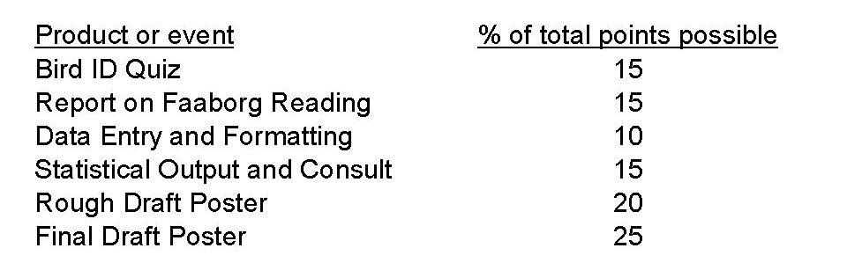
Figure 5. Suggested grading rubric.

Comments on the Formative Evaluation of this Experiment:

I have taken two approaches to formative evaluation of this experiment. First, I have used the questions listed under Questions for Further Thought And Discussion to evaluate to the degree to which students understand the concepts fundamental to their hypotheses (Q1-3), the methods they will use to test their hypotheses (Q4-5), and the applications of their results to conservation (Q6-7). I assign sets of questions at strategic intervals throughout the experiment so that I can correct any misunderstandings with written feedback and discussion before we move to the next step in the experiment. I have found that this approach corrects misconceptions before they snowball and prevents students from abandoning all hope of understanding the experiment because they did not understand fundamental concepts presented in early steps. Second, I periodically assign and review responses to minute papers on important and confusing concepts. These papers help me identify barriers to learning that I did not anticipate and how to adjust my list of Questions for Further Thought And Discussion.

Comments on Translating the Activity to Other Institutional Scales or Locations:

In general, this experiment readily translates to many different settings. It translates to medium-sized classes (10-18 students) by increasing the number of groups. With more groups, the class can cover more hypotheses (e.g., nestedness by habitat degradation) and multiple taxa. While the later may require the help of a lab coordinator or teaching assistant to collect field data, it is instructive to compare how well fragment area and isolation explain nestedness of taxa varying in their general dispersal ability (e.g., most frogs and salamanders do not disperse as well as birds). In fact, the instructor may not wish to use birds at all if the academic schedule does not align with bird breeding season, if he does not feel comfortable surveying birds in an afternoon lab, or if he is particularly comfortable with another taxon. Many assemblages are nested, regardless of taxonomic status and ecosystem identity. I firmly believe that this experiment does translate to classes populated by students with little exposure to organism identification, if you (the instructor) are comfortable with bird identification and provide students with teaching tools mentioned in the section titled Comments on Data Collection and Analysis Methods Used in the Experiment.

This experiment is not appropriate for students with physical disabilities or for pre-college courses.

Instructions for using NestedSim.exe

The Basics
Nested uses a simple simulation program designed by Mark Lomolino to test whether biotic assemblages are nested by a variable of the user’s choice. The program requires a current PC operating platform (Windows 2000, Windows XP, or Windows emulator on a Macintosh) and a carefully formatted input file.

NestedSim.exe is available on the TIEE website in multiple file formats. Click here to visit the downloads page in your web browser.

Formatting the Data for Input
The file must be comma delimited. This can be achieved by saving an excel spreadsheet with a .csv extension. Rows must represent sites. In order from left to right, columns must represent fragment area, fragment isolation, and species.

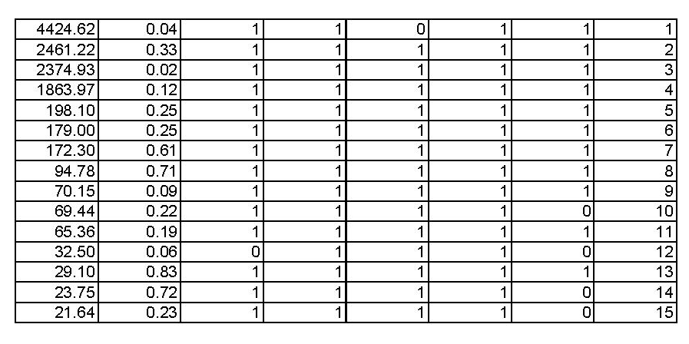
Figure 6. Example of a formatted input file in .xls format. For the program to read the file, it must be converted to .csv format.

Values for area and isolation must be entered with at least one decimal place. Column 3 through column n+2 (where n = number of species detected across all fragments) must represent species. Use a one to denote presence and a zero to denote absence. Now, sort rows in your input file using fragment area (the highest value must be in the top row) and add a final column (column n+3) that contains the row number.

NOTE: After testing for nestedness with respect to area, the program will test for nestedness with respect to isolation. For this second test, it will sort the rows so that the value of the variable in column two decreases from the top of the matrix to the bottom of the matrix (i.e., the program assumes a negative correlation between the variable in column two and species richness).

Performing the Test
Once you have formatted the input file, open program Nested and type in the complete path to that file (e.g., c:/temp/NestedSimIn.txt). Click the checkfile box and compare the numbers of sites and species read by the program to known values. If these numbers appear correct, set the number of random simulations you prefer (1000 is standard) and click the run box. The large simulation window will show the progress of the simulations and confirm the number of simulations selected. When the simulations are complete, values will appear in the bottom five windows. Calculate the final test statistic:

Percent Perfect Nestedness = 100 * ((R-D)/R).

Note: the output includes a D-value for both area and isolation, so be careful which D-value you select when calculating percent perfect nestedness.

Example Data
You have been provided with a text file of formatted example data named NestedSimIn.csv. It is composed of 29 sites and 20 species. D_{area} equals 87. D_{isolation} equals 110. R, P-values, and percent perfect nestedness will vary with each test, but they should be near the following: R = 107, P-value_{area} < 0.01, P-value_{isolation} > 0.5, percent perfect nestedness with respect to area ~ 19.

STUDENT DATA COLLECTED IN THIS EXPERIMENT

At the current time, there are no student datasets available. However, the instructions for using NestedSim.exe includes a sample dataset from Fleishman et al. (2007).

COPYRIGHT STATEMENT
The Ecological Society of America (ESA) holds the copyright for TIEE Volume 6, and the authors retain the copyright for the content of individual contributions (although some text, figures, and data sets may bear further copyright notice). No part of this publication may be reproduced, stored in a retrieval system, or transmitted, in any form or by any means, electronic, mechanical, photocopying, recording, or otherwise, without the prior written permission of the copyright owner. Use solely at one's own institution with no intent for profit is excluded from the preceding copyright restriction, unless otherwise noted. Proper credit to this publication must be included in your lecture or laboratory course materials (print, electronic, or other means of reproduction) for each use.
To reiterate, you are welcome to download some or all of the material posted at this site for your use in your course(s), which does not include commercial uses for profit. Also, please be aware of the legal restrictions on copyright use for published materials posted at this site. We have obtained permission to use all copyrighted materials, data, figures, tables, images, etc. posted at this site solely for the uses described in the TIEE site.
Lastly, we request that you return your students' and your comments on this activity to the TIEE Managing Editor (tieesubmissions@esa.org), for posting at this site.

GENERIC DISCLAIMER
Adult supervision is recommended when performing this lab activity. We also recommend that common sense and proper safety precautions be followed by all participants. No responsibility is implied or taken by the contributing author, the editors of this Volume, nor anyone associated with maintaining the TIEE web site, nor by their academic employers, nor by the Ecological Society of America for anyone who sustains injuries as a result of using the materials or ideas, or performing the procedures put forth at the TIEE web site, or in any printed materials that derive therefrom.

