ISSUES : DATA SET
Global Temperature Change in the 21st Century

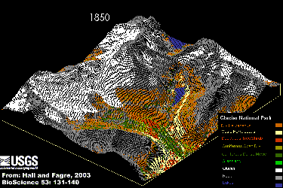
Daniel R. Taub^{1,2} and Gillian S. Graham ¹

1 - Biology Department, Southwestern University, 1001 East University Ave, Georgetown, TX 78626

2- Corresponding author: Daniel R. Taub (taubd@southwestern.edu)

THE ECOLOGICAL QUESTION:
How might global temperatures change during the 21st century? How might these changes vary geographically, seasonally, and depending upon future human activities?
One possible effect if global temperatures rise is the melting and retreat of glaciers, such as depicted in this simulation for Glacier National Park, Montana USA. By Myrna H. P. Hall and Daniel B. Fagre, 2003 [Public domain], via Wikimedia Commons.

ECOLOGICAL CONTENT:
Abiotic environment, global change, global warming, climate change, greenhouse gases, latitudinal gradients, seasonality

WHAT STUDENTS DO:
Students consider how to detect trends in large data sets against a background of variation. They use output from global climate models to examine projected climate change during the 21st century under a range of greenhouse gas emissions scenarios. Using Excel, they graph projected changes in temperature at particular locations over time and perform linear regressions. They compare projections of temperature change among emissions scenarios, across latitudinal gradients and between seasons. These exercises are adaptable to studying a wide range of climate parameters at any terrestrial location.
STUDENT-ACTIVE APPROACHES:
Guided group discussions take place throughout. Some discussions take place first within small groups and then are expanded to the larger class (Think-pair-share). Students consider questions, design and conduct analyses, and make comparisons. Student groups combine data analyses using a jigsaw approach.

SKILLS:
Working in groups, working with spreadsheets, detecting and comparing trends in data and making inferences, presenting data using figures, comparison of data collected in different locations and under different conditions, report writing.

ASSESSABLE OUTCOMES:
Students produce graphs and statistical analyses and orally present and discuss their findings. If instructor desires, they also may produce a written report.

SOURCES:
Canadian Centre for Climate Modelling and Analysis. Online data repository, http://www.cccma.ec.gc.ca/data/data.shtml

ACKNOWLEDGEMENTS:
We thank the Canadian Centre for Climate Modeling and Analysis for making available the data from their climate models. Dr. Gregory M. Flato provided help in obtaining permission to use this data, and suggested useful approaches for using climate model output. Students in various editions of DRT’s Global Change Biology class provided valuable feedback on these exercises. The editor and two anonymous reviewers provided numerous helpful suggestions.

OVERVIEW OF THE ECOLOGICAL BACKGROUND
Human industrial activity, use of fossil fuels, and land use changes have been leading to increasing emissions and atmospheric concentrations of carbon dioxide and other greenhouse gases (Figure 1). Greenhouse gases are ones that allow electromagnetic radiation (light) at the wavelengths emitted by the sun to pass through to the Earth’s surface, but absorb the radiation that is emitted by the Earth out toward space. In this fashion, they act to heat the atmosphere near the Earth’s surface. Recent increases in the concentrations of these gases, along with increases in temperature, have been the basis for concerns about “global warming.”
Major changes in climate that might result from such increased concentrations of greenhouse gases could of course have profound implications for agriculture, human health, natural resources, and a host of other areas of ecological and social importance. To anticipate these effects, we must first anticipate the details of projected changes in climate. For example, how much warming can be expected to occur over the next century? How would different social, economic, and technological developments affect greenhouse gas emissions and climate change? Would warming be truly global, or vary from location to location? Would warming occur mostly in summer (affecting the prevalence of heat wave, heat damage to crops, etc.), mostly in winter (potentially decreasing the severity of winters, affecting sea ice formation, etc.) or equally in both?
Since these questions concern the future, they cannot be answered directly by empirical observation- unless we are willing to wait decades for the answers. We have only one Earth, so we cannot directly perform experiments with the climate system (other than the one we are inadvertently performing). To make detailed predictions about the future, researchers therefore must rely on perturbing simulated Earths rather than the actual Earth. It would be impossible in a physical simulation (such as a giant globe) to capture the processes in the

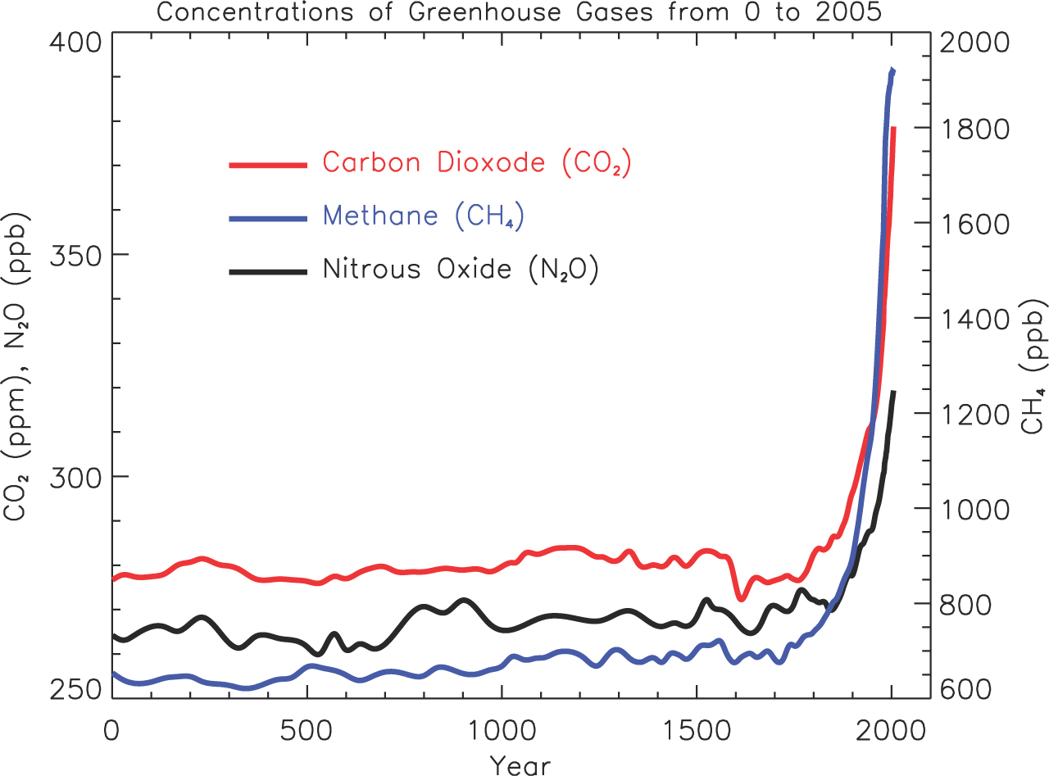

Figure 1. Atmospheric concentrations of greenhouse gases have been rising rapidly in recent years. Reprinted from Faq 2.1, Figure 1 of Solomon, S., D. Qin, M. Manning, Z. Chen, M. Marquis, K.B. Averyt, M. Tignor and H.L. Miller (eds.) Contribution of Working Group I to the Fourth Assessment Report of the Intergovernmental Panel on Climate Change, 2007.Cambridge University Press, Cambridge, United Kingdom and New York, NY, USA. Used with permission.

Earth’s complex systems in a realistic and meaningful way. Researchers therefore rely on computer simulations that mathematically represent the chemical, physical and biological complexities of global climate systems and how they inter-react and respond to changes in external conditions (such as increasing emissions of CO₂ from the burning of fossil fuels).
In practice, there are two major steps to predictions of the effects of future human activities on climate. The first is to predict the quantities of greenhouse gases, particulate matter, and other substances that will be emitted into the atmosphere. The second is to use these estimates of emissions as inputs into models that simulate global climate.

Table 1: Characteristics of Selected Emissions Scenarios. These scenarios represent alternative possibilities for future social and technological change as envisioned by a range of governmental and non-governmental analysts. Adapted from Nakicenovic, N. and R. Swart, eds. (2000). Special Report on Emissions Scenarios (Cambridge, U.K., Cambridge University Press).

Scenario characteristics | A1B | A2 | B1
Human Population growth | Low | high | low
Globalization, economic convergence among regions of the world | High | low | high
Increases in social and political emphasis on environmental sustainability | Low | Low | High
Economic growth | very high | medium | high
Land- use changes | Low | medium/high | high
Pace of technological changes in energy use | Rapid | slow | medium
Changes in energy use and production | rapid: changes in both energy production and use | slow: vary by region | medium: emphasis on efficiency of use and shift to lowered use of materials
Energy use | very high | high | low

Future anthropogenic emissions of gases such as CO₂ will vary greatly depending on the rates of human population growth and industrialization and the development and spread of new technologies, such as alternatives to fossil fuels for energy generation. The climate change community has therefore developed a variety of different emissions “storylines” and scenarios that describe alternative versions of future social, economic, and technological changes (Table 1). Each scenario, with its different projections of social, economic and technological changes generates different predicted quantities of emissions and atmospheric concentrations of carbon dioxide (Figure 2) and other greenhouse gases.
Climate simulation models then are used to predict future climates under these different emissions scenarios. Typically, these models divide the surface of the Earth, the ocean and the atmosphere into large spatial cells (Figure 3). Each cell has specified physical properties; for example, a cell in the atmosphere will have a specified temperature, pressure, humidity, etc. In the model, time is simulated in steps; for each step the chemical and physical properties of each cell are updated as the cell receives radiation from the sun and Earth, exchanges energy and materials with adjacent cells, etc. One can use such models to

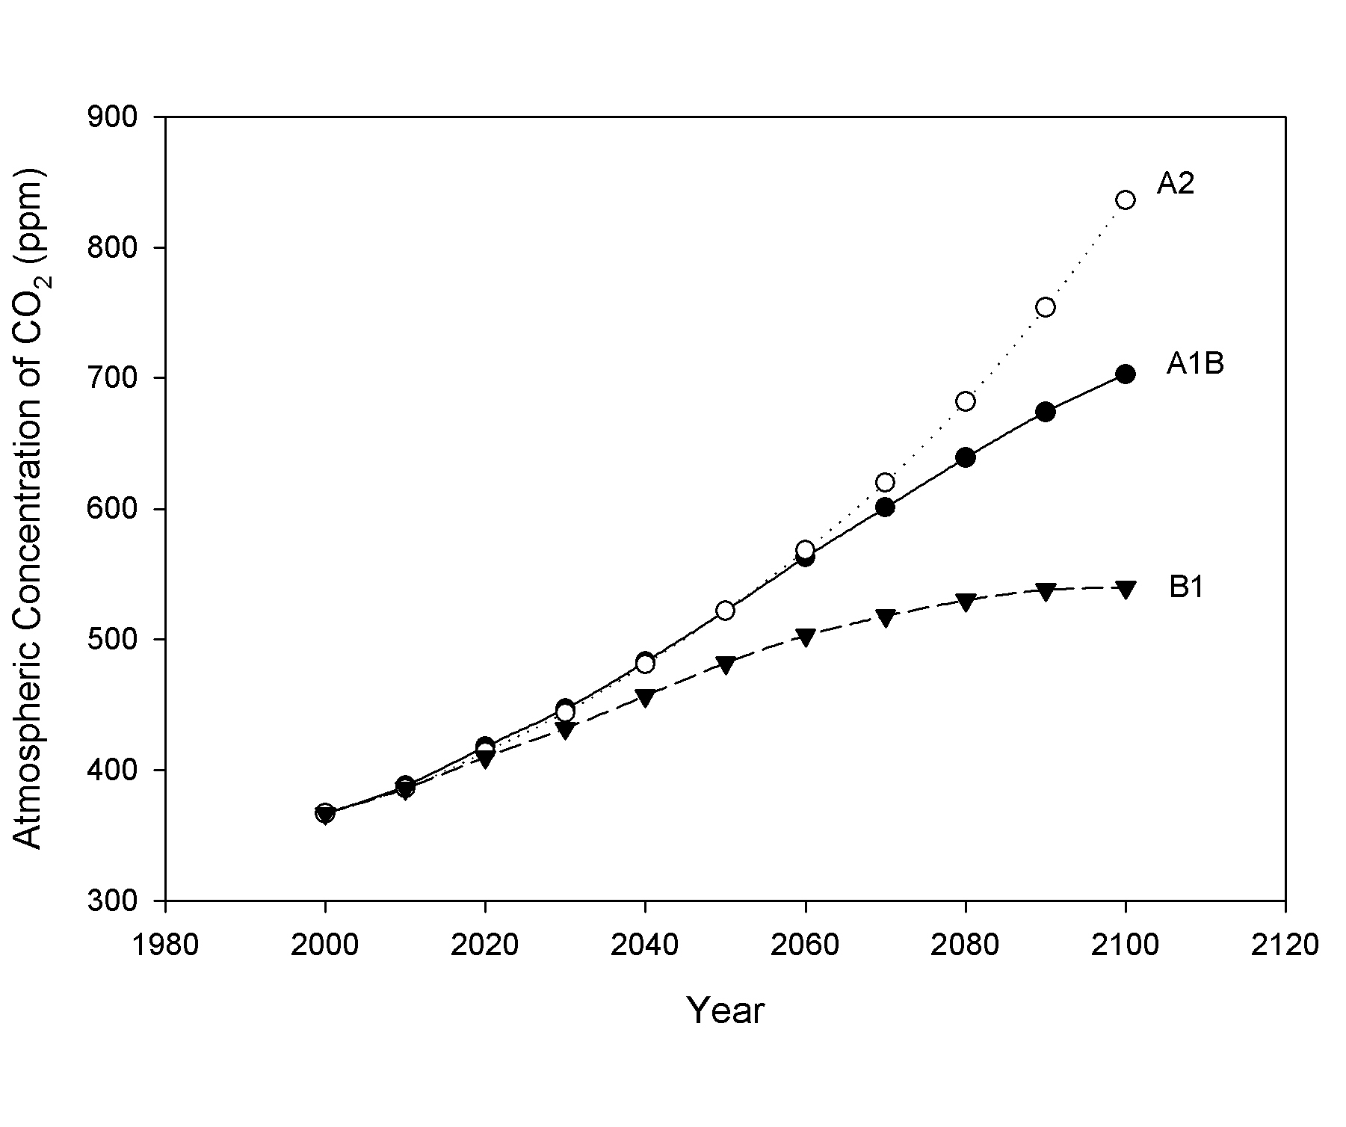

Figure 2. Projected atmospheric concentrations of CO₂ for the 21st century. Data is from the Bern-CC (reference model from Appendix II In: Climate Change 2001: The Scientific Basis. Contribution of Working Group I to the Third Assessment Report of the Intergovernmental Panel on Climate Change. Houghton, J.T.,Y. Ding, D.J. Griggs, M. Noguer, P.J. van der Linden, X. Dai, K. Maskell, and C.A. Johnson, eds. Cambridge University Press, Cambridge, United Kingdom and New York, NY, USA).

predict changes in any of these physical and chemical parameters, in any location within the Earth-atmosphere system.
In these exercises, students work with output from simulations of future climates performed using models developed by the Canadian Centre for Climate Modeling and Analysis (CCCma), focusing on near-surface air temperature, a concept familiar through daily weather reports. In doing so, students develop increased understanding of how predictions of future climate are derived, as well as practicing skills in analysis and interpretation of large data sets.
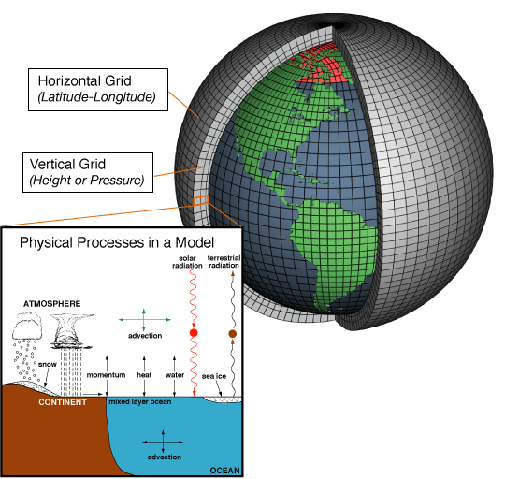

Figure 3. Global climate models simulate physical processes, representing the Earth and atmosphere with a three-dimensional grid. Source: National Oceanographic and Atmospheric Administration [Public Domain]. Via Wikimedia commons.

STUDENT INSTRUCTIONS

Background on the data

In these exercises, you will work with output from one set of climate models, created by the Canadian Centre for Climate Modeling and Analysis (CCCma), who have kindly made the results of a number of runs of their models available online. Information on the models can be found on the Models section of the CCCma website (http://www.cccma.ec.gc.ca). We will be using data from their third-generation (CGCM3) model. This is the latest model for which they have made available extensive climate predictions over nearly the entirety of the Earth’s surface. We will focus on one parameter, temperature above surface, defined as the air temperature 2 m above the Earth’s surface. This corresponds to the familiar air temperature reported in the daily weather report in newspapers and on TV.
The data you will examine is the mean temperature (°K) for each month over the 100 years (2001-2100), giving a total of 1200 values for the 1200 consecutive months. You are provided these data for the three scenarios described in Table 1 (A1B, A2, and B1) and for a fourth set of conditions representing “Committed” climate change. The “Committed” set of conditions assumes that the composition of the atmosphere remains unchanged at year 2001 values. Therefore, the only climate changes that will occur are those to which the climate system is already committed due to past changes in atmospheric concentrations. The Committed scenario is not intended as a realistic scenario. Instead, it serves as a control for comparison with the other scenarios. By comparing the results of a given scenario with the results under the Committed scenario, one can see how much additional climate change a scenario produces compared to what would be produced if alterations in climate forcing agents were to immediately stop.

For each scenario, we provide data for 19 grid cells in a continuous North-South transect through North America (Figure 4). Your instructor will assign you or your group a latitude or latitudes to work with.
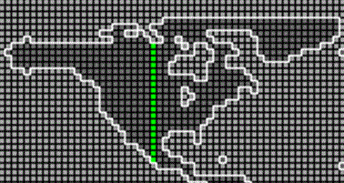
Figure 4. Location of the data transect through North America. Screenshot from Canadian Center for Modelling and Analysis website, http://www.cccma.ec.gc.ca/cgibin/data/cgcm3/cgcm3_a1#id1, November 11, 2010.

Pre-exercise: Detecting and interpreting trends

In your groups, discuss the following questions to help you consider how you will organize and analyze your data.

- What would be the best graphical format for presenting the data to illustrate changes (if any) in temperature across the century?

- How should you organize and analyze the data to determine: 1) whether or not a meaningful trend exists, and 2) how much the temperature has changed (if at all) over the course of the century?

These questions will be discussed with the entire class before you continue on to the exercises below.

Exercises

Exercise 1: Comparison of temperature trends among emissions scenarios

1. Examine the data spreadsheet. Notice the variables that are included, how the data is organized, and the time period it spans.

2. Make a graph showing how summer (July) temperature varies across the 100 years of this study. Begin with the Committed scenario. Only graph the data for your assigned latitude. You will want Year to be the x axis of the graph and Temp to be the y axis. Select these columns (but only for those rows in which the month is July). Use the graphing tools of Excel to create a scatterplot with these values; choose the plot that includes only data points and no connecting lines.

3. Label the axes appropriately, including units. Give the figure an appropriate, detailed title. Since you and the class will be creating a number of different figures, it will be important to have a title that distinguishes among them, including the range of years depicted, the dependent variable, the latitude, and which scenario was used.

4. Insert a trend line (linear regression), including the equation and the R² value. You can do this by clicking on one of the data points in the figure. This should select the entire series of data points. You can then choose add trend line from the Chart menu (the location of this command may vary with the version of Excel).

5. Note the slope from the trend line equation. Based on this analysis, explain in words how much July temperature changed per year over the time period analyzed.

6. Now, graph the remaining three scenarios for your specific latitude, and add the trend lines to each graph (you will have four total). Note the slope for each equation.

7. Change the scale for the x and y axes for each of your figures. You can do this by clicking on the axis in the finished figure, and then changing the scale values. Set the range of X and Y values for all figures so that they are the same for each figure. This allows for visual comparison of the regression lines.

8. With your group, discuss how temperature has changed in each scenario.

9. Come together as a class so each group can briefly share its findings.
- Are there any patterns as to which scenarios show changes in temperature across the century, or show the greatest change?
- What might differences in projected climate change under these scenarios be due to?
- What might differences among scenarios indicate about future climate change?

Exercise 2: Comparison of temperature change across seasons

1. Repeat Exercise 1, using data from winter (January).

2. Come together as a class for each group to briefly share its findings.
- Does temperature change seem to be more pronounced in one season than in the other?
- What implications might the seasonality of future climate change have for potential impacts (social, ecological, medical, etc.) of climate change?

Exercise 3: Latitudinal Comparisons

1. As a class, devise an approach to share the details of your findings (i.e., the magnitude of temperature change over the century for each analysis you have performed).

2. Once everyone has access to all of the results, each group should examine the results.
- What is the geographic pattern of temperature change? Was it greater at some latitudes than at others? Did it differ between arctic and tropical regions?

3. Discuss these findings as a class.
- What implications might latitudinal patterns of climate change have for the impacts (social, ecological, medical, etc.) of future climate change?

Notes to Faculty
Description of Excel files
- Student dataset (This file contains data for 19 latitudes.) [xlsx]
- Faculty dataset (This file contains data contains data for 19 latitudes, and the faculty file additionally contains the regression slopes and R-squared values for regressions of temperature on year for both January and July for each of the latitudes under the three emissions scenarios in Table 1, and under an additional set of conditions that represent a control set of conditions (the Committed scenario) under which concentrations of greenhouse gases remain constant at year 2000 concentrations.) [xlsx]
Additional Resources
- Student assignment [doc]
- Appendix 1: Downloading additional model output [doc]
- Appendix 2: Kelvin to Celsius Conversion [doc]

Using different, or additional data
The data included in the spreadsheets with this data set is only a tiny fraction of the climate model output available from the Canadian Centre for Climate Modeling and Analysis. Downloading the data and arranging it in a spreadsheet in a useable form is not difficult, but does take a bit of work and some understanding of spreadsheet data manipulation. We have provided detailed instructions on how to do so in Appendix 1. Some of the reasons you may want to download data yourself include:
- To include the geographic location where your institution is located
- To include other geographic areas of particular interest
- To have students examine potential future trends in variables other than air temperature, such as precipitation, soil moisture, snow cover, sea ice cover and thickness, etc.

You also may choose to have students download data for themselves using the instructions in Appendix 1. Some potential advantages of this include:
- Students can choose their own geographic locations of interest
- Students can better understand the source of the data if they download it themselves
- Students can practice and develop skills in data manipulation
- Students can be assigned work to be done outside of class in which they download and analyze data independently

In practice, one of us (DRT) has found that students who have some previous experience with spreadsheets are able to download and process the data for themselves. However, he also has found that students often get stuck if things do not go exactly as planned, due to minor mistakes in the use of the spreadsheet program, variation in the spreadsheet commands from one software release to another, and the like. It is therefore recommended that if students are going to download data for themselves that:
- Students be instructed to register with the CCCma website ahead of time (see Appendix 1)
- The instructor(s) first download and process a set of data using the same equipment and software that the students will use
- If possible, the instructor(s) modify the instructions in Appendix 1, providing details applicable to the particular equipment and software to be used. This may be particularly important for unzipping the compressed files that are downloaded. No instructions on doing this have been provided in Appendix 1, as this process can vary greatly across computer systems.
- The instructor(s) rotate among the students as they are downloading and processing data for the first time, helping to solve problems as they occur

Running the class
For students who have prior experience with Excel, the entire sequence from pre-exercises through exercise three can be easily accomplished within one three-hour lab period. There is often a good deal of heterogeneity among students in their familiarity with Excel. When groups of students finish an exercise quickly, it is usually useful to enlist these students as temporary teaching assistants to help groups that are struggling with spreadsheet procedures.

Pre-exercises
The pre-exercises ask students to think about how to approach finding patterns in data. This helps students to understand the rationale for the procedures used in the exercises to create and analyze the graphs. In the class discussion of the pre-exercise questions, the instructor can guide students toward more sophisticated ideas of how to approach the data. Some of the naïve conceptions that have come up include:
- Some students suggest simply comparing the temperature in 2001 to that in 2100. Others suggest averaging the data for the first ten and last ten years of the experiment. With these answers it is helpful to guide discussion to how the inherent variability in weather from year-to-year might affect the results of these approaches. It is also helpful to discuss the value of including all available data. If students have had some prior exposure to statistical techniques, they will often derive for themselves the value in using a linear regression approach.
- Even students with some experience in statistics may not immediately appreciate that the slope is the appropriate indication of the magnitude of temperature change. Some students suggest that the r-squared is a measure of the magnitude of change. If the students discuss this as a class, it doesn’t take students long to realize that the slope is the appropriate measure.
- Some students suggest graphing all the data from month 1 through month 1200, with month on the x axis and temperature on the y axis. To address this idea, ask the students to draw a rough sketch of what such data might look like, taking into account seasonal variation. Ask if they would be likely to detect a long-term change of one or two degrees. Students then often realize that the seasonal pattern may overwhelm the long-term trend. Students can then be asked how to detect an inter-annual trend against the background of seasonal changes. Usually students will come up with the answer implicit in these exercises: analyze trends in the data for a single month.

Assigning data to students
We have provided data across 19 grid cells on a North-South transect through North America. In the Student data workbook, each data sheet contains data for a different latitude. To facilitate comparisons along the latitudinal gradient, we suggest assigning each student or group a different latitude. If you will have fewer than 19 students/groups, you can either spread the students out across the latitudinal gradient (for example assigning latitudes 1, 4, 7, 10, 13, 16 and 19) or have each group analyze the data for more than one latitude.

Checking student findings
In the Faculty data workbook, we have provided (in addition to the data in the student data workbook) the slopes and R² values for the linear regression of temperature on year for every combination of scenario, latitude and month (January or July) in the data set. These can be used to check that students have properly performed their analyses.

Kelvin to Celsius conversion
We have provided the temperature data in degrees Kelvin rather than degrees Celsius. The Kelvin scale is commonly used in the physical sciences and is the scale used by the CCCma for their data output. Since an interval of one degree is equal in the two scales, the slopes that students analyze and compare will be identical using either scale. If you wish to have students convert from Kelvin to Celsius, we have provided detailed instructions in Appendix 2 that can be shared with students.

Exercise 1
Students are asked to compare changes in July temperature across the century among the different scenarios. Across the entire transect, the average change in July temperature for scenario A2 is 0.051°K per year, for A1B it is 0.037°K per year, for B1 0.023°K per year and for the Committed scenario it is 0.002°K per year. Students may need to be guided to see that these small rates of change per annum add up to 2 to 5 degrees of warming over the 21st century.
One question that students may ask is “Why is there so much variation from year to year in the model output?” The answer is that these models have stochastic components. So the simulated weather will vary from day to day and from year to year much in the way it does in the real world.
Students will generally be able to spontaneously relate the differences among the scenarios to the differences in greenhouse gas concentrations (Figure 2) that result from different assumptions about future social and technological change (Table 1).
In discussion about what the differences among scenarios indicate about future climate change, students often will spontaneously mention (or are easily prompted to mention) that:
- The future is inherently uncertain
- The future of climate change is likely to depend on factors under human control

Exercise 2: Comparison of temperature change across seasons

Students are asked to compare the magnitude of temperature change in July and in January. The patterns are somewhat complex. At low latitudes, temperature change tends to be greater in July than in January. At high latitudes, the pattern is reversed; temperature change is greater in January than in July.
Some students may confuse “low latitude” with “southern hemisphere.” They will interpret low latitude “July” as being winter and “January” summer. Students may need to be reminded that the data they are analyzing is all from the northern hemisphere.
Students may be curious about why January temperatures increase across the century for the Committed scenario. This is particularly true for the high latitudes. The Committed scenario represents not unchanging climate, but unchanging greenhouse gas concentrations. Increases in greenhouse gas concentrations that have already occurred will take some time to exert their full effects on climate. This is why the scenario is called “Committed”. Anthropogenic increases in greenhouse gas concentrations have already committed global climate to future changes, even if we could maintain the atmosphere at its current composition.
In discussion of the implications of the differences in warming across seasons, students may come up with (or be guided to mention):
- Temperature increases at high latitude are expected to be most pronounced in the winter. Phenomena such as the melting of lake and marine ice may be affected by climate change to a stronger extent than might be imagined from looking at the mean annual temperature change.
- The direct health effects of temperature changes at higher latitudes might consist of a beneficial effect due to amelioration of winter cold, and a detrimental effect due to increased summer heat.
- Low latitude areas may experience an increase in temperatures that is particularly pronounced at the hottest times of the year. This might produce a variety of detrimental effects on human health and agriculture.

Classroom discussion of the seasonal effects should reveal the strong differences in temperature change across the latitudinal gradient. This flows nicely into exercise 3, in which students share the details of their analyses with one another.

Exercise 3: Latitudinal Comparisons

Students are asked to figure out a scheme to share their results (i.e., the slopes). They may make a table on the board, or a projection system, pass around papers with their results, etc. It doesn’t matter, so long as each group gets access to all of the results.

Students are asked to examine the geographic pattern of temperature change. In addition to the latitudinal differences in the seasonality of temperature change noted in exercise 2, students should discover that the overall magnitude of temperature change is greatest at higher latitudes.

In discussion of the implications of the differences in warming across the latitudinal gradient, students may come up with (or be guided to mention):
- Temperature changes may have their most profound effects on high-latitude ecosystems.
- Given a general pattern toward global warming, species and ecosystems might shift their ranges over time toward higher latitudes. The species and ecosystems currently at the highest latitudes might have nowhere to shift to.
- Human adjustment to climate change will depend both on the magnitude of climate change in a region (greater at high latitudes), and on the resources required to make appropriate social and technical changes. The current global distribution of economic resources shows a general increase of wealth with latitude.

Additional activities:
There are a large number of climate models that have been developed and used to simulate climate over the 21st century under the commonly used emissions scenarios. It can therefore be instructive to compare projected future climate across models. The IPCC data distribution center has assembled the results from a large number of runs of various models (including the CCCma model used in these exercises). One of the easiest ways to access this data is at
http://www.ipcc-data.org/cgi-bin/ddc_nav/dataset=ar4_gcm
This provides an easy button interface to select particular models, scenarios, climate parameters and time periods. Results are provided as 30-year averages in a tabular form, allowing for easy comparison across models.

Student Assessment:
Student performance can be evaluated for any of the activities involved in these exercises, including graphing, analysis and interpretation of data, and explanation and interpretation of differences in projected climate change among scenarios, seasons and latitudes.
If students have downloaded data for themselves (Appendix 1) they can be assigned to download, analyze and interpret additional data outside of class. This requires students to analyze and interpret data in a truly independent fashion, and allows for evaluation of performance in spreadsheet manipulation of large data sets.
An example of an assignment that has students use a standard research report format to present their analyses can be downloaded here.

COPYRIGHT STATEMENT
The Ecological Society of America (ESA) holds the copyright for TIEE Volume 7, and the authors retain the copyright for the content of individual contributions (although some text, figures, and data sets may bear further copyright notice). No part of this publication may be reproduced, stored in a retrieval system, or transmitted, in any form or by any means, electronic, mechanical, photocopying, recording, or otherwise, without the prior written permission of the copyright owner. Use solely at one's own institution with no intent for profit is excluded from the preceding copyright restriction, unless otherwise noted. Proper credit to this publication must be included in your lecture or laboratory course materials (print, electronic, or other means of reproduction) for each use.
To reiterate, you are welcome to download some or all of the material posted at this site for your use in your course(s), which does not include commercial uses for profit. Also, please be aware of the legal restrictions on copyright use for published materials posted at this site. We have obtained permission to use all copyrighted materials, data, figures, tables, images, etc. posted at this site solely for the uses described at TIEE site.

GENERIC DISCLAIMER
Adult supervision is recommended when performing this lab activity. We also recommend that common sense and proper safety precautions be followed by all participants. No responsibility is implied or taken by the contributing author, the editors of this Volume, nor anyone associated with maintaining the TIEE web site, nor by their academic employers, nor by the Ecological Society of America for anyone who sustains injuries as a result of using the materials or ideas, or performing the procedures put forth at the TIEE web site, or in any printed materials that derive therefrom.

