Document 3. Understanding Co-Evolution through integration of biological databases

Student Learning Outcome: To gain an understanding of the importance of integrating datasets to arrive at evolutionary relationships of co-evolving species. Here, you will focus on understanding the life cycles, distribution, and species interactions of zombie snail parasites.

Define the following:
Life Cycle:-
Parasite-
Obligate Parasite-
Host Specialist-
Host generalist
Species distribution-

Part 1: Co-evolutionary relationships of parasites and their hosts: Lifecycles

As you have learned from previous exercises, zombie snail parasites are a family level designation for several genera and species. As such, we will focus on the genus seen in the videos, Leucochloridium. Using this specialization, we will track down the rest of the players in the life cycle.

First, the snail host.
- To begin with, open OneZoom Tree of Life Explorer and choose zombie snail parasite from the main search tab. You will find that this is the common name zombie snail parasite.
- Open Wikipedia and choose Leuchochloridium variae, the species from the video. Next, view the life-cycle section and find the name Succinea. This is the genus of land snails infected by this parasite.
- Return to OneZoom Tree of Life Explorer and choose Succinea.

Question: What is the common name of this genus of snails?

- Click on the image of the parasitized snail.

Question: What is the common and scientific name of this species of snail?

Next, a bird host.
These snails are eaten by a wide variety of songbirds, but we will focus on a common species: the black and white warbler.
- Open OneZoom Tree of Life Explorer and choose the black and white warbler.

Question: What is the scientific name of this bird species?

Question: Now, write all the species’ names listed in the lifecycle.

Before understanding the distributions of the species in the lifecycle of a zombie snail parasite, let’s back up and understand the life cycle of this parasite. You can read about it on Wikipedia and learn that the immature larvae and adult worms live in different hosts.

Question: In what host does the non- reproductive larval worm life stage occur?

Question: In what host does the reproductively mature adul life stage occur?

Part 2: Co-evolutionary relationships of parasites and their hosts: Distributions- Maps

In this section, you will create global distribution maps of the parasite, bird, and snail based on location data uploaded by researchers. This technique allows us to view the degree of spatial overlap shared by each species in the life cycle. This is a great way to understand interaction strength based on the likelihood that the parasite and host will be in contact with each other.

  - In OneZoom, In the search all life box, enter zombie snail parasite (The node should show the genus Leucochloridium). Click on the node so that the box below appears.

  - The Occurrence link (on a cell phone this will appear as a green leaf) links to the Global Biodiversity Information Facility (GBIF). A very powerful database that includes locality information of all species found in OneZoom. Click on Occurrence and a global map with yellow dots should appear. The dots are localities where the species was observed by a researcher and the coordinates were shared with the curators of this database.

  - Take a screenshot of the map and paste it below. Make sure the image is labeled with the common and scientific name of the parasite species.

  - Repeat steps A through C for the snail and bird species found in the parasite life cycle. Make sure the bird map and the snail map are each labeled with the common and scientific name. You will have three maps displayed below.

Question: What is the main region (continent) where each species is found?
Parasite-
Bird-
Snail-

Consider the life cycle of the parasite and its hosts. Based on the maps, there are differing levels of geographic overlap between species. strong (a few differences in data points), moderate (overlapping continental scale, but mismatch between many datapoints), weak (mostly overlap at continental scale but few points overlap at smaller (e.g. state size) geographic scales.

Question: Based on the maps, state what level of overlap occurs for each species combination below.

Parasite/snail --
Parasite/bird --
snail/bird –

Question: Based on the maps, which species is most reported? Why?

Question: Based on the maps, which species is most likely the least studied? Why?

Part 3: Co-evolutionary Relationships of parasites and their hosts: Ecological Interactions

Although the lineages of the bird, snail, and parasite diverged millions of years ago, the species alive today all have strong interactions with each other and other organisms in their environment. These interactions of today shape the evolutionary patterns of tomorrow.

The Global Biotic Interactions Database search (globalbioticinteractions.org) allows us to view these interactions in interesting ways. Please watch this video to understand how this tool helps us to understand that all species interact with other species- nothing lives in a vacuum! Watching these short videos will make conducting the exercises below much easier!!!
2019-09-27_10-33-54 on Vimeo

Also- a more simplified video showing some of the functions is found here.
Global Biotic Interactions Introduction (2 Minutes, March 2014) on Vimeo

To access this database through the connections in OneZoom, follow the directions A-D below:

- Back to OneZoom, In the search all life box, enter zombie snail parasite. Zoom into the node and click on it to open the Wikipedia link. Notice, there are other options:
- Click on Genetics to enter website for National Center for Biological Inventory. You will enter the Taxonomy Browser home page. .***IF you need to refer back to this page for later use without starting again at OneZoom, use this link: Taxonomy browser (root) (nih.gov))

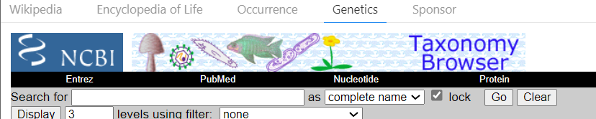

- Now it is time to find the interactions between the parasite and its hosts through the linkout options in NCBI Taxonomy Browser.
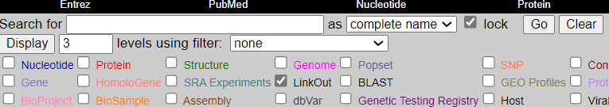

- Leucochlorodium now has a word “linkout” in blue next to the name. Click on the linkout and choose The Global Biotic Interactions database from the Provider Home Page.

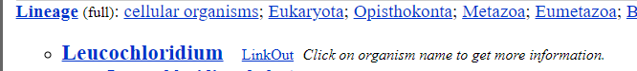

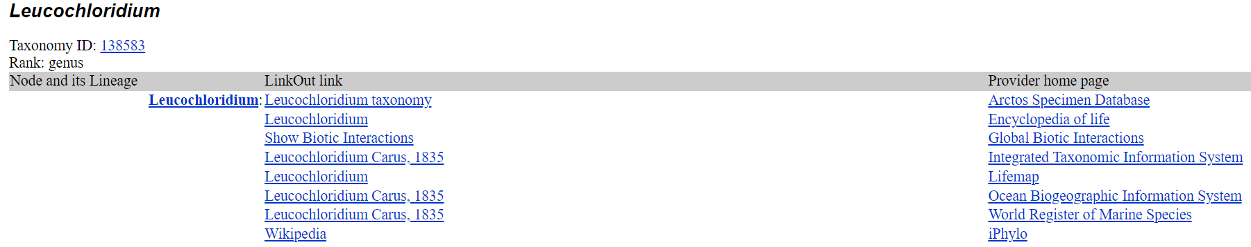

Now: The Global Biotic Interactions (GloBI) database.

- In the main page you will see a query. After “do” enter zombie snail parasite so that Leucochoridium appears in the box. Next, choose parasitize for the interaction.
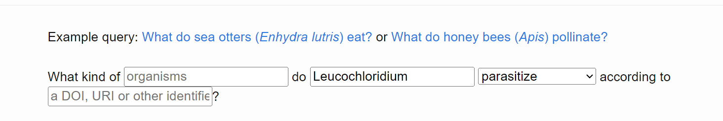

- Next, click on the the open results in interaction browser tab when the image below appears on the screen.

Question: How many taxa (taxon column) do zombie snail parasites parasitize according to this database?

Question: How many snail taxa in taxon column do zombie snail parasites parasitize according to this database?

Now, we will look at the numbers of species that the bird, snail, and parasite interact with in their environments.

- Go back to the main page and enter the zombie snail parasite species, Leucochloridium variae, and choose interacts with for the interaction box.

- Next, choose the bundle diagram (lower right panel in the interaction browser), maximize the image, and paste it below. Repeat this step for the snail and bird species in the life cycle.
Leucochloridium variae interactions
Succineum putris interactions
Mniotilta varia interactions

Question: Based on the bundle diagrams, what taxon has the fewest interactions?

Question: Based on your answer above, what are two reasons for this phenomenon?

